State of Estuary Report
for Georges Bay

April 2007 to March 2008

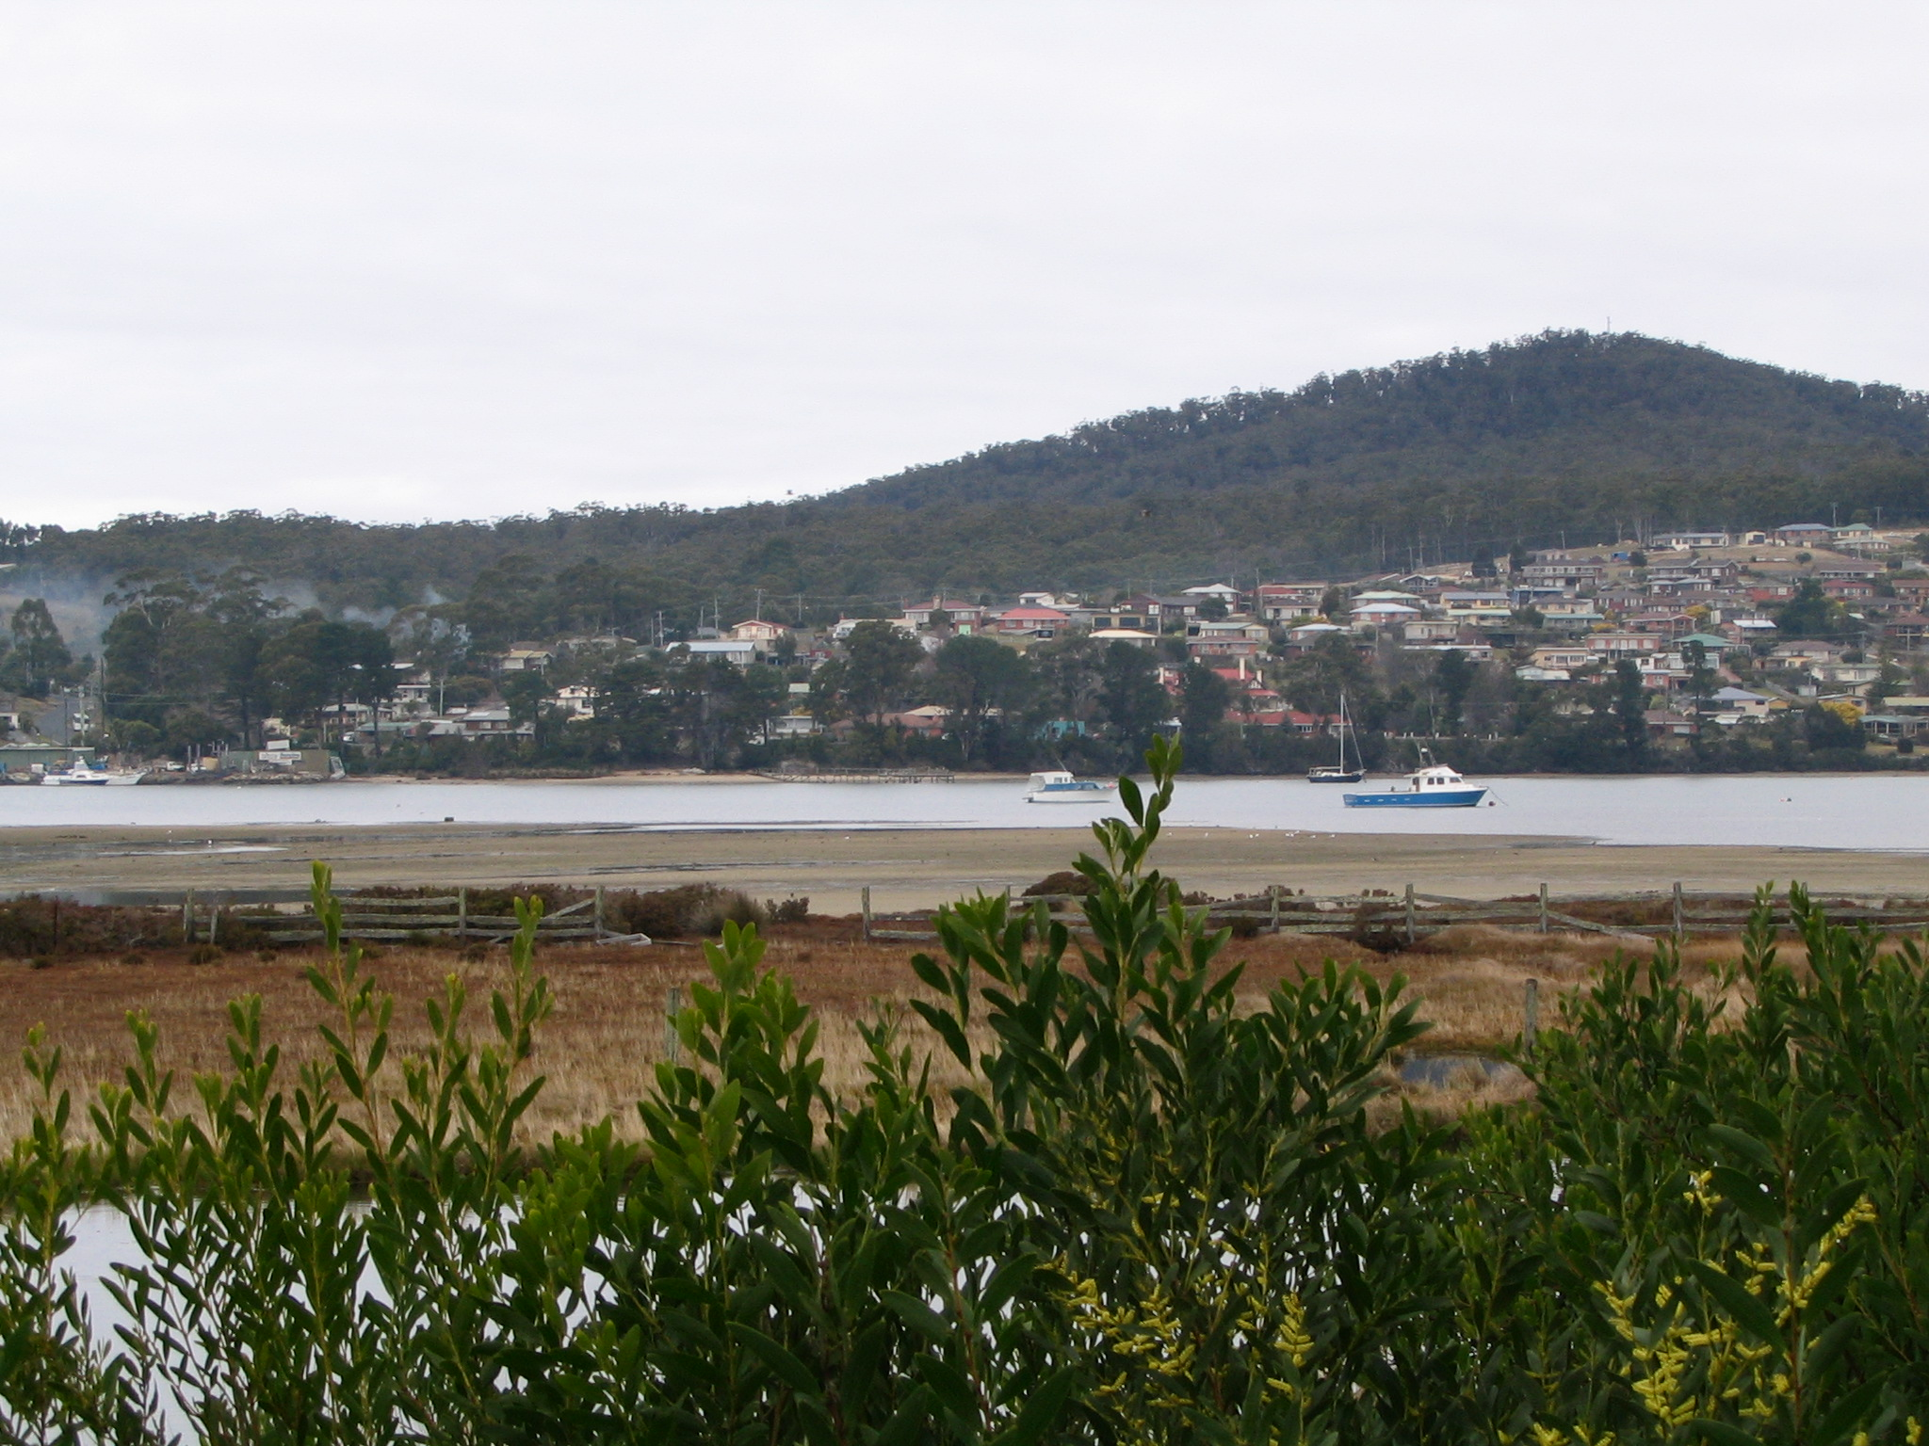

Christine Crawford and Kylie Cahill
Tasmanian Aquaculture and Fisheries Institute



Executive Summary

Indicators of estuarine ecosystem health – temperature, salinity, turbidity, dissolved oxygen, chlorophylla, pH, nutrients - were sampled each month for twelve months at four sites in Georges Bay and at the bridge at the river mouth by the Tasmanian Aquaculture and Fisheries Institute (TAFI). community volunteers and Break O’Day Council staff. Another indicator, macroinvertebrate fauna, was sampled by TAFI in winter and summer, and data were obtained on pathogen levels from the Tasmanian Shellfish Quality Assurance Program.

The results from these surveys are provided below and are compared with the data from 2004-05. Overall the bay appears to be in reasonable condition and is not showing any clear signs of degradation. However, the increased nitrate plus nitrite levels in the bay, the low summertime dissolved oxygen level in bottom waters near Medusa Cove and the increased numbers of introduced pest species in the macroinvertebrate fauna are cause for concern. The high nitrate levels and absence of macroinvertebrate fauna at the bridge near the mouth of the estuary suggest an impacted system.

Basic measures of ecosystem  condition | July 04 – June 05 | April 07 – March 08
Temperature | normal | normal
Salinity | normal | normal
Dissolved oxygen  (especially bottom waters) | no data, BOD above guide  lines at sewage outfall | Generally normal, ex below 60%  at Medusa Cove Jan 08
Turbidity | Limited data | Mostly low, ex medium  peaks after flood
Chlorophyll-a | Not monitored | Low-medium, ex peaks in Jun 07 in  bay & Mar 08 at bridge
Habitat extent | Monitored 2005  Available SeaMap Tas website | Not monitored
Important indicators
Animal and plant species  abundance | Not monitored | Lower estuary normal, upper estuary  signs of impact, incl. introduced  species, bridge impacted.
Shoreline position | Not monitored | Being established
Nutrients in the water | NOx - few high values especially Bridge site, NH4 - mostly low, no PO4 data | NO_{x} in bay low over summer, high  peaks in winter, Bridge site regularly  high. PO₄, NH₄ normal for Tas.  Estuaries.
Toxicants | No chemicals above detectable limits in water or oyster meat samples | Not monitored
Pathogens | Low in estuary, high at Bridge site | low % of samples with high  thermotolerant coliforms
pH | Limited data, mostly within limits except ex at sewage outfall | Normal, within 7.0-8.5
Community monitoring
Algal blooms | Not monitored | None recorded
Mass mortalities | Ongoing low level oyster mortalities, no mortalities of native species | None recorded
Litter | Not monitored | Not monitored
Invasive species |  | Not directly monitored

Table of Contents

Executive summary…………………………………………………………….2

Introduction …………………………………………………………………….5

Methods …………………………………………………………………………6
Sampling sites……………………………………………………………...6
Indicators…………………………………………………………………..8
Sampling procedures……………………………………………………....9
Data from other sources………………………………………………….10
Analysis of dat ……………………………………………………….…..10
Interpretation of data…………………………………………………….11

Results and Discussion ……………………………………………………… 14
Rainfall……………………………………………………………..…….14
Temperature…………………………………………………………… 15
Salinity……………………………………………………………………15
Turbidity………………………………………………………………….15
Oxygen…………………………………………………………………....15
pH………………………………………………………………………..15
Chlorophyll a……………………………………………………….…….16
Nutrients………………………………………………………………… 16
Macroinvertebrates………………………………………………………24
Pathogens……………………………………………………………...…27

Conclusions……………………………………………………………………28

Acknowledgements …..………………………………………………………29

References ……………………………………………………………………30

Appendix A Invertebrate species data

Appendix B Manual for the Assessment of the Health of Georges Bay: Community Monitoring

Introduction

The Tasmanian Aquaculture and Fisheries Institute (TAFI) was contracted by NRM North to participate in the implementation of the Integrated Water Quality Monitoring Framework for Georges Bay via a community and expertise based monitoring program.

The Objectives of this project were to:
- Develop an estuary monitoring module building on the quality assurance procedures and protocols developed by Waterwatch,
- Train a community and a technical estuary monitoring team,
- Collect additional baseline data in conjunction with local monitoring teams,
- Produce an annual State of Estuary Report.

The field work component of this project was conducted over twelve months from April 2007 to March 2008.

This project builds on previous work conducted by TAFI in partnership with NRM North and Break O’Day Council. The environmental information available on Georges Bay to 2005 was summarized in a report by Crawford and White (2005) on ‘Establishment of an integrated water quality monitoring framework for Georges Bay’. It included recommendations for a preliminary monitoring program and provided a draft report card for the health of Georges Bay for the twelve months July 2004 to June 2005. Subsequent to this report a recommended set of indicators for monitoring the condition of coastal, estuarine and marine environments around Tasmania (Table 1) was developed by the Tasmanian Coastal, Estuarine and Marine Indicators Working Group, called the 'Tasmanian NRM Estuarine, Coastal and Marine Resource Condition Indicator Compendium' (Mount et al 2006). This recommended set of indicators is detailed in The Tasmanian Indicator Compendium, draft form available at: http://www.environment.tas.gov.au/cm_draft_tasmanian_estuarine_coastal_marine_indicators.html. A summarized, working version of the Tasmanian Indicator Compendium entitled ‘Indicators for the condition of estuaries and coastal waters in Tasmania’ was written by Crawford (2006), available at http://eprints.utas.edu.au/view/authors/Crawford,_C.html.

Table 1. Indicators recommended for monitoring in Tasmanian estuarine, coastal and marine waters (Mount et al 2006).

Indicators recommended for monitoring
Tasmanian estuarine, coastal and marine waters
Basic measures of ecosystem condition
Temperature
Salinity
Dissolved oxy Dissolved oxygen (especially bottom waters)
Turbidity
Chlorophyll-a
Habitat extent
Important indicators
Animal and plant species abundance
Shoreline position
Nutrients in the water
Toxicants
Pathogens
pH
Community reporting
Algal blooms
Mass mortalities
Litter
Invasive species

These Tasmanian indicators are a subset of the national indicator set and are those that are considered to be a high priority for monitoring in Tasmania. Information on the national indicator set is available on the Australian Government Caring For Our Country website, available at http://www.nrm.gov.au/publications/factsheets/me-indicators/index.html#ecmhi.

Methods
Sampling sites

Five sites in Georges Bay were monitored each month (Fig. 1). These sites were selected to be representative of different areas of the bay and where possible to be the same as those that had been monitored previously, thus enabling comparisons of data over time. Sites GB1, GB2 and GB4 were sampled by TAFI in 1993-94 (Crawford and Mitchell 1999), and samples GB3 and GB5 by Sinclair Knight Mertz from November 2004 to June 2005 (SKM 2005). Visual references and GPS co-ordinates for the monitoring sites are given in Table 2. Not all environmental parameters were monitored at Site GB3.

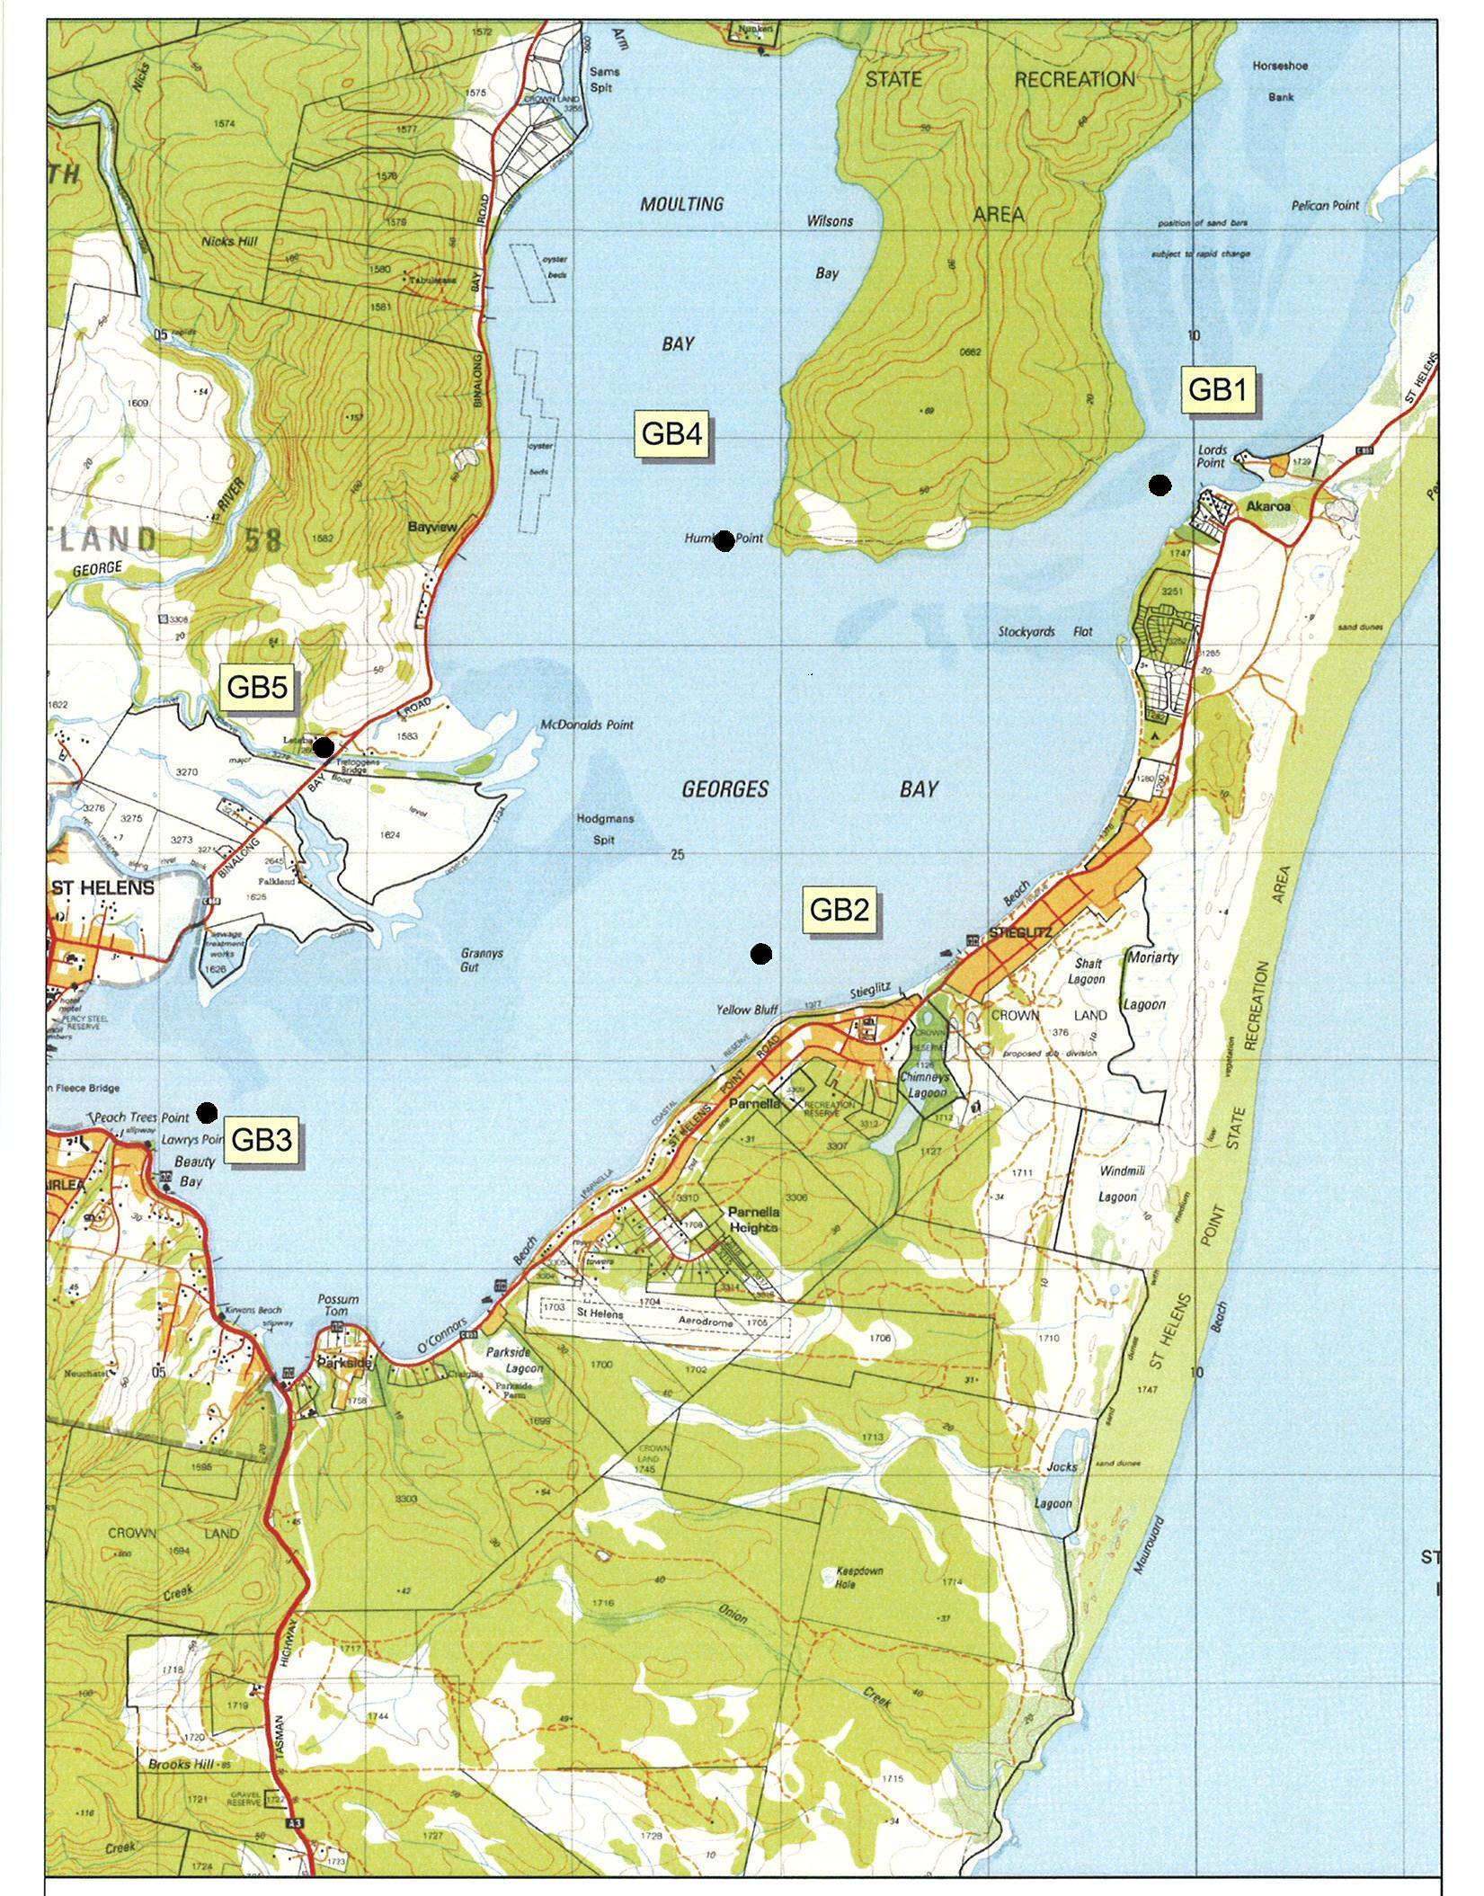

Fig. 1. Map of five water sampling sites in Georges Bay.

Table 2. Visual references and GPS co-ordinates for Georges Bay monitoring sites

Site | Description | GPS Co-ordinates
GB1 | Green navigation pylon in the centre of the  channel slightly south west of Lords Point | 5426947 N 609946 E
GB2 | At the base of the Yellow Bluff cliffs, level with  the last house on the top of the Stieglizt end of the  bluff approximately 200m off shore | 5424691 N 608014 E
GB3 | An equal distance between the red navigation  pylon and Lowrys Point | 5423922 N 605346 E
GB4 | Approximately 200m off Humbug Point in a  westerly direction, an equal distance between the  point and the northern most yellow corner marker  of the nearby oyster lease | 5426681 N 607836 E
GB5 | In the creek on the western side of Treloggen  Bridge on the Binalong Bay road | 5425683 N 605902 E

Indicators

The indicators monitored in this project to assess the condition of Georges Bay were a subset of those recommended by the Tasmanian Coastal, Estuarine and Marine Indicators Working Group (Table 1). Additional environmental data were also sourced from other surveys conducted in the bay.

These indicators have been chosen to give an overall picture of the health of Georges Bay. They are not targeted at point sources of pollution. The indicators recommended, which are a combination of physical/chemical and biological variables, are considered to be the minimum set for cost-effective assessment of the condition of the bay. There are a number of other variables that could be monitored but it is important that the same minimum set of variables is monitored using the same methods each time to be able to detect any change in condition.

Indicators monitored monthly for twelve months (April 2007 – March 2008) from the five sites as part of this project were temperature, salinity, dissolved oxygen, pH, turbidity, chlorophyll a, and nutrients (nitrate and nitrite, phosphate, ammonium and silicate). Using the same sampling procedures as previously used in Georges Bay, water column variables were collected during the outgoing tide and preferably as close to slack low tide as possible. The benthic invertebrate fauna were sampled in two seasons, winter and summer.

Sampling procedures
Temperature, salinity and dissolved oxygen, were measured at the surface and at the bottom using portable field meters with probes which were lowered through the water column. pH and turbidity were measured at the surface only using portable meters.

Water samples for nutrients - nitrate plus nitrites, dissolved reactive phosphorous and ammonium, were collected at each site at the surface and filtered according to procedures and equipment supplied by Analytical Services Tasmania (AST), frozen overnight and later analysed by AST.

Chlorophyll a concentrations were determined by collecting one litre of surface water at each site and filtering onto 20μm filter paper on the day of sampling. The filtrate was frozen and later analysed in the laboratory for chlorophyll a using a spectrophotometer.

Georges Bay community members assisted with the collection of these field measurements and water column samples. They received training in the sampling procedures so that they could continue the monitoring after the project finishes. Further details of sampling procedures are provided in “Manual for the Assessment of the Health of Georges Bay: Community monitoring” by Crawford and Cahill (2007), which is appended to this report.

Animal and plant species abundance was investigated by TAFI from sampling the macroinvertebrate fauna in the sediments at four sites in the Bay. The composition of the macroinvertberate infauna and species abundance is considered to be representative of fauna and flora in estuaries and a good indicator of the ecology of the system because soft sediments are the dominant substrate type in estuaries and the infauna are relatively stationary and long lived. Also, the invertebrate fauna in estuarine sediments have been widely sampled in Tasmania and thus there is a substantial knowledge base of these animals. The samples were collected and processed according to standards protocols used by TAFI and described in a number of publications (for details of the sampling method see: Macleod C. and Forbes S. (2006). Guide to the assessment of sediment condition at marine finfish farms in Tasmania, available at http://www.utas.edu.au/tafi/PDF_files/Field%20Manual_FINAL.pdf).

Triplicate samples were collected using a van veen grab at the sites in the estuary and a PVC pipe corer in the river at the low tide mark. The sediment samples were sieved through a 1mm sieve in the field and the remaining contents were fixed in 10% formalin. In the laboratory macroinvertebrates were identified to species level where possible and counted.

Data from other sources

Shoreline position in Georges Bay is being monitored as part of TASMARC (Tasmanian Shoreline Monitoring and ARChiving) project, which is being coordinated by John Hunter, University of Tasmania. A site, at the corner of Tasman Highway and St Helens Point Road was identified as suitable for shoreline monitoring. TASMARC is coordinating with St Helens high school to conduct the monitoring.

The Tasmanian Shellfish Quality Assurance Program (TSQAP) provided data on temperature, salinity, rainfall, wind direction and thermotolerant coliforms collected approximately monthly from several sites in the bay. TSQAP routinely monitors shellfish growing waters according to the requirements of an internationally accepted program for the reduction of food safety risks for shellfish consumption. The sampling complies with the Australian Shellfish Quality Assurance program to test that the shellfish are grown in clean, unpolluted waters. Annual reports and Triennial data reviews for shellfish growing areas in Tasmania are now available on the internet at:http://www.dhhs.tas.gov.au/health__and__wellbeing/public_and_environmental_health/related_topics/tasmanian_shellfish_quality_assurance_program

Habitat extent was not conducted as part of this project as Georges Bay was mapped by TAFI in 2005, including the sea grass beds. This map is available at http://www.utas.edu.au/tafi/seamap/ Because habitat mapping requires considerable expertise and funding it is recommended that the bay is mapped every five years; next in 2010.

Toxicants were not included in the monitoring program because NRM North was obtaining expert advice on methods to monitor contaminants in the most cost-effective and scientifically valid manner. This information was not available during this project.

The indicators algal blooms and mass mortality events, which are particularly suited to community monitoring, were discussed at the training program. These events occur sporadically and local community members are most likely to be in place to record them if they occur. A mass mortality data record sheet and instructions on taking samples from a mass mortality event were provided to the community and local council trainees. Since the manual was written a national protocol for fish kills was released and minor changes have been made to the record sheet in line with recommendations from the ‘National Investigation and Reporting Protocol for Fish Kills (DAFF 2007).

Although methods for assessment of litter were provided to the community trainees, this was not monitored as part of the training program because of time constraints and litter is not a major risk to ecosystem health.

Invasive species also were not specifically monitored because this requires taxonomic expertise and is expensive to conduct. State Government has no plans to conduct further surveys of introduced pests at the port of St Helens (A. Morton DPIW, pers.comm.). Apparently surveys of marine flora and fauna have been conducted in Georges Bay in relation to proposed developments but this information is normally not available to the public because it is commercial-in-confidence. It is recommended that Local and State Governments endeavour to make this information available to monitoring programs where possible.

Analysis of data

A multi-dimensional scaling (MDS) analysis of the macroinvertebrate data from each estuary was conducted. MDS is a standard analytical technique commonly used by ecologists to compare macroinvertebrate communities from different sites. This technique is described in texts on statistical methods for biological sciences (e.g. Quinn and Keogh 2002) and in reports and publications from TAFI on macroinvertebrate fauna, available at http://www.tafi.org.au/). MDS takes into account the similarity/dissimilarity of the species composition and abundance of each species between sites and displays these differences graphically. The more different sites are with respect to species composition and abundance, the further apart they are on an MDS plot.

Note that the data on water column variables are presented as continuous line graphs to assist presentation and interpretation of the results. However, these samples were only collected monthly and are not continuous data.

Interpretation of data

The results obtained were compared to ANZECC guidelines (ANZECC 2000) (Table 3). However, it should be noted that these guidelines were developed without including any data from Tasmanian estuaries or coastal waters and therefore these default trigger values should be used with caution. For example, in a previous survey of nutrients in Georges Bay NOx (nitrate plus nitrite) values at a marine site just outside the bay were consistently higher than the ANZECC guideline trigger value for NOx in marine waters (Crawford et al 1999). Similarly, other estuaries in south-eastern Tasmania often have NOx concentrations that are higher than ANZECC guidelines due to the influx of nutrient rich sub Antarctic waters (Crawford and White 2005). The 80th and 20th percentiles have also not been included because ANZECC guidelines request a minimum of 24 months of sampling before determining these percentiles.

Table 3. ANZECC WATER QUALITY GUIDELINES – AQUATIC ECOSYSTEMS for South-east Australia, including Tasmania.

 | Chl a | TP | TN | NO_{x} | NH₄⁺ | DO (% saturation) |  | pH
 | μg L⁻¹ | μg L⁻¹ | μg L⁻¹ | μg L⁻¹ | μg L⁻¹ | Lower limit | Upper limit | Lower limit | Upper limit
Upland River | NA | 13 | 480 | 190 | 13 | 90 | 110 | 6.5 | 7.5
Lowland River | 5 | 50 | 500 | 40 | 20 | 85 | 110 | 6.5 | 8.0
Estuariesª | 4 | 30 | 300 | 15 | 15 | 80 | 110 | 7.0 | 8.5
Marine | 1 | 25 | 120 | 5 | 15 | 90 | 110 | 8.0 | 8.4
a = These values were ascertained without using Tasmanian estuarine or marine data – a precautionary approach should be adopted when applying these default trigger values.

The results were also compared with data from other surveys of water quality in Tasmanian estuaries, the most comprehensive being by Murphy et al (2003). They surveyed 22 estuaries bimonthly from July 1999 to June 2000, and from these data developed draft indicator levels for turbidity, chlorophyll a , nitrates+nitrites and phosphates for Tasmanian estuaries (Table 4).

Table 4. Water quality in 22 Tasmanian estuaries and draft indicator levels (Murphy et al 2003).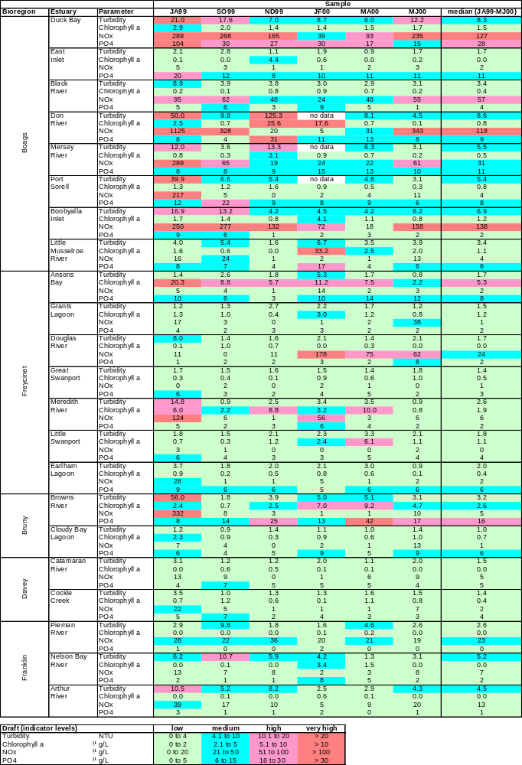
Draft indicator levels
Low Medium High Very High
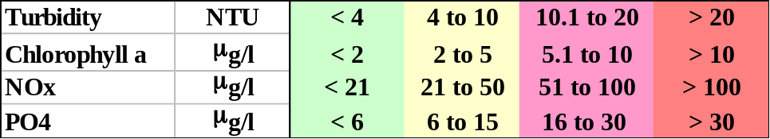

Results and Discussion

Rainfall at St Helens aerodrome for the sampling period is shown in Fig. 2 (data sourced from Bureau of Meteorology website). Unfortunately the flow data at the St Helens water supply, which is good measure of water flow into Georges Bay from the river, is not reliable for the sampling period due to instream operations.
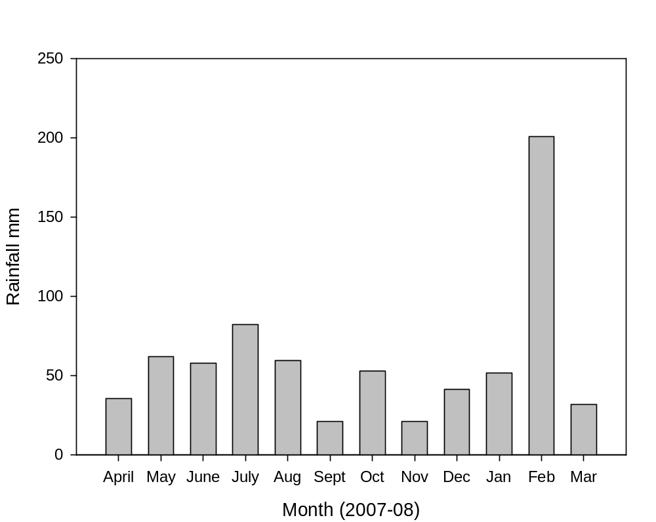

Fig. 2 Monthly rainfall at St Helens during the sampling period

Temperature
As temperature is a key factor controlling the rate of biological processes it is important supporting information, rather than a direct indicator. It is essential information in determining dissolved oxygen and pH, and temperature records over long periods of time (decades) are an indicator of global warming.

Water temperature in the bay varied little between surface and bottom waters and between sites in the estuary (Fig.3). As expected, the highest and lowest values were recorded at the shallow site at the bridge GB5, 24.1º in January 2008 and 6.3º in June 2007. The greatest difference between surface and bottom waters occurred at sites GB2 and GB3; higher at the surface in summer (by 2.8º at G3 in January) and lower at the surface in winter (by 2.6 º at GB2 in August).

Salinity
Salinity of the bottom waters of the estuary was marine (i.e. >33) throughout the sampling period, except for a small decline during the month of highest flows (Fig. 4). This was most evident at the site at the entrance to Moulting Bay GB4 and in the channel of Lords Point GB1. Surface water salinity was also largely marine in the estuary except during periods of high rainfall in August 2007 and in February 2008. Within the bay the lowered salinity due to floods was most evident at GB2, off Yellow Bluff. Site GB5 at the bridge in the lower river always consisted of freshwater.

Previous measurements of salinity in the bay have also been largely marine, except during and after rainfall events when the lowest salinities generally occur in Moulting Bay and near the George River outflow (Crawford and White 2005).

Turbidity
Turbidity levels were consistently low at the entrance to the estuary and increased at sites further up the estuary (Fig. 5). The highest values were at the bridge site, with peaks in August 2007 when the monthly flow rates were highest for the sampling period, and in January 2008 (reason unknown). Even so, these values were not excessively high compared to other estuaries around Tasmania (see Table 4). There have been few previous measurements of turbidity in Georges Bay and these have been low, although anecdotal evidence for Moulting Bay suggests high levels of turbidity (Crawford and White 2005).

Oxygen
Dissolved oxygen was always high in the lower estuary (Fig. 6). Bottom water dissolved oxygen hovered around 80% saturation at GB3 below Medusa Cove in most months, but was relatively low (<60%) in January 2008. Regular sampling of bottom water DO at this site in the warmer months of the year is recommended. DO also dropped below 80% at GB4 in June 2007. Other than these readings, dissolved oxygen values were generally above levels that can impact on the ecology of the system. GB5 at the bridge had relatively high dissolved oxygen on several occasions. Reasons for the above average DO levels at all sites in October 2007 are not clear and suggest possible instrument malfunction. ANZECC guidelines for estuaries are an upper limit of 110% and lower limit of 80% saturation.

pH
pH was in the range of 7.9-8.5 at all sites within the bay with little variation between sites (Fig. 7). Site GB5 in the river showed considerably more variation in pH; even so the range of 7.6-8.5 was narrow. These values are indicative of a healthy system. They fall within the ANZECC guidelines of 7.0 - 8.5 for pH in estuaries. Previous measurements of pH at six sites in the bay in 2004-05 by Saunders (unpublished data) were also neutral to alkaline. Acid sulphate soils are considered to be a potential issue in the catchment (Crawford and White 2003), however there are no signs of this in the estuary.

Chlorophyll a
The average chlorophyll a values, which are an indicator of primary productivity, were generally low and <2 μg/l (Fig. 8). A peak occurred in June 2007 at all sites sampled in the bay, to a maximum of nearly 6 μg/l at site GB2.A further peak occurred in February 2008 at sites in the bay, again with the highest values at GB2. At site GB5 at the mouth of the river a major peak of >9 μg/l was observed in March 2008.

Chlorophyll a concentrations measured by Crawford and Mitchell (1999) were higher, generally in the range of 1-4 μg/l, with a peak in July 1993 of 13.5 μg/l and around 7 μg/l in February 2009. These values were generally higher after rainfall events, presumably due to nutrients being flushed into the estuary.

Nutrients
Silicate concentrations were lowest at GB1 the most oceanic site, were low and fluctuating at sites GB2 and GB4 (mostly <2 mg/l), and were much higher at the freshwater river entrance site of GB5 (ranging between 7 and 10 mg/l) (Fig. 9). These values are similar to other estuaries, with higher concentrations during floods and in freshwater.

NOx (nitrate + nitrite) concentrations were generally lowest at GB1, furthermost down the estuary, and the variability in results between monthly readings increased as the sites became more freshwater influenced (Fig. 10). A peak occurred at all sites in August 2008 when freshwater flooding occurred, as shown by the lower salinity values in the bay. This peak was highest at sites GB2 and GG5. Concentrations of nitrates plus nitrites in the bay were regularly above ANZECC guidelines for estuaries of 15 μg/l, but exceeding this guideline is common in Tasmanian estuaries (Crawford and White 2005). Only the peak concentrations were in the high range (51-100 μg/l) recommended in the draft indicator levels for Tasmanian estuaries by Murphy et al (2003) (Table 4). A significant peak also occurred in October 2007 at site GB 4 only. Concentrations at the bridge GB5 had the most consistently higher values, which were well above the ANZECC guidelines for lowland rivers of 40μg/l.

These peak values in the bay are considerably higher than the maximum values of approximately 65 μg/l recorded in winter 1992/93. At this time the highest NOx concentrations were regularly recorded at the marine site outside the estuary (Crawford et al 1999). A comparison of NOx concentrations between 2007/08 and 2004/05 indicated little change at GB1, higher values at GB2 and higher peaks at GB5 in this study than previously.

Ammonia concentrations were relatively consistent across the sampling period and were around 20 μg/l or less, except for peaks in April and May 2007 of up to 60 μg/l at sites in the bay (Fig. 11). Site GB4 was the most variable during the sampling period, whereas site GB 5 was the most consistent and had the lowest concentrations. This implies that the higher ammonium values within the bay are sourced from within the bay. Other than the peaks, these concentrations are slightly above the ANZECC guidelines of 15 μg/l.

Phosphate values were consistently low across all sites and were rarely above 10 μg/l (Fig. 11). This is above the ANZECC guidelines of 5 μg/l and within the medium range of 6-15 μg/l recommended as a draft indicator level for PO₄ in Tasmanian waters (Murphy et al 2003). Similarly phosphate concentrations recorded in Georges Bay in 1993/94 were around or below 10 μg/l (Crawford and Mitchell 1999).

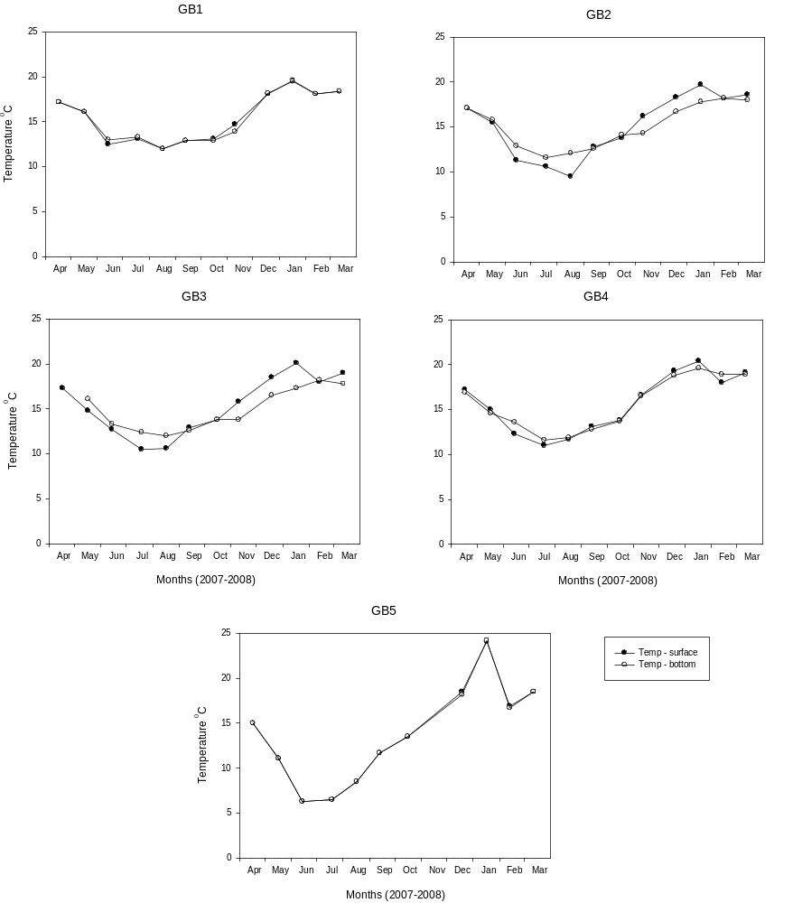

Fig. 3. Surface and bottom water temperatures in Georges Bay and the river entrance.
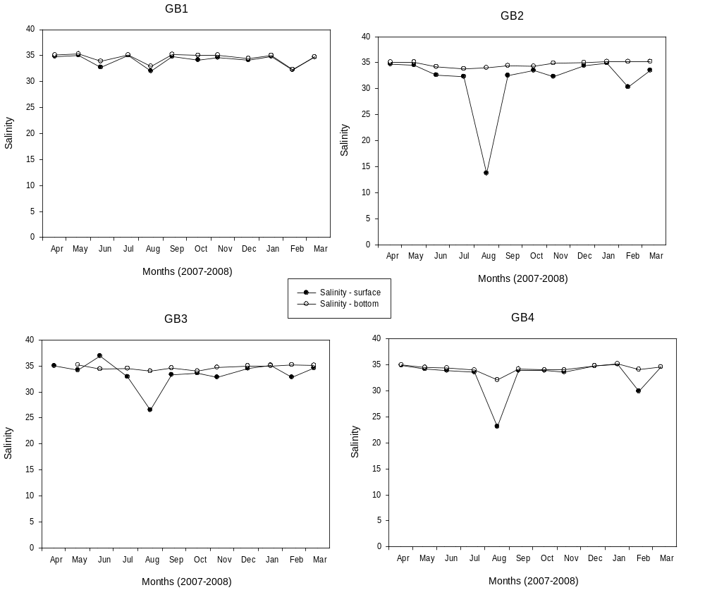

Fig. 4. Surface and bottom water salinities in Georges Bay. Site GB5 at the bridge consistently had a salinity of 0.

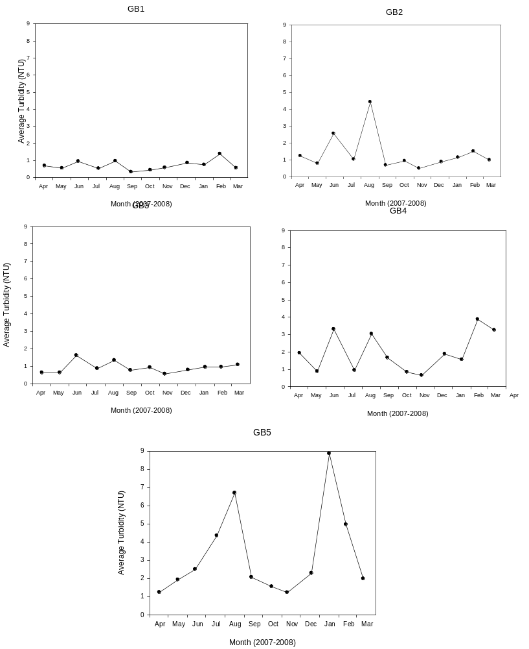
Fig. 5. Turbidity in surface water at sites in Georges Bay and the river entrance

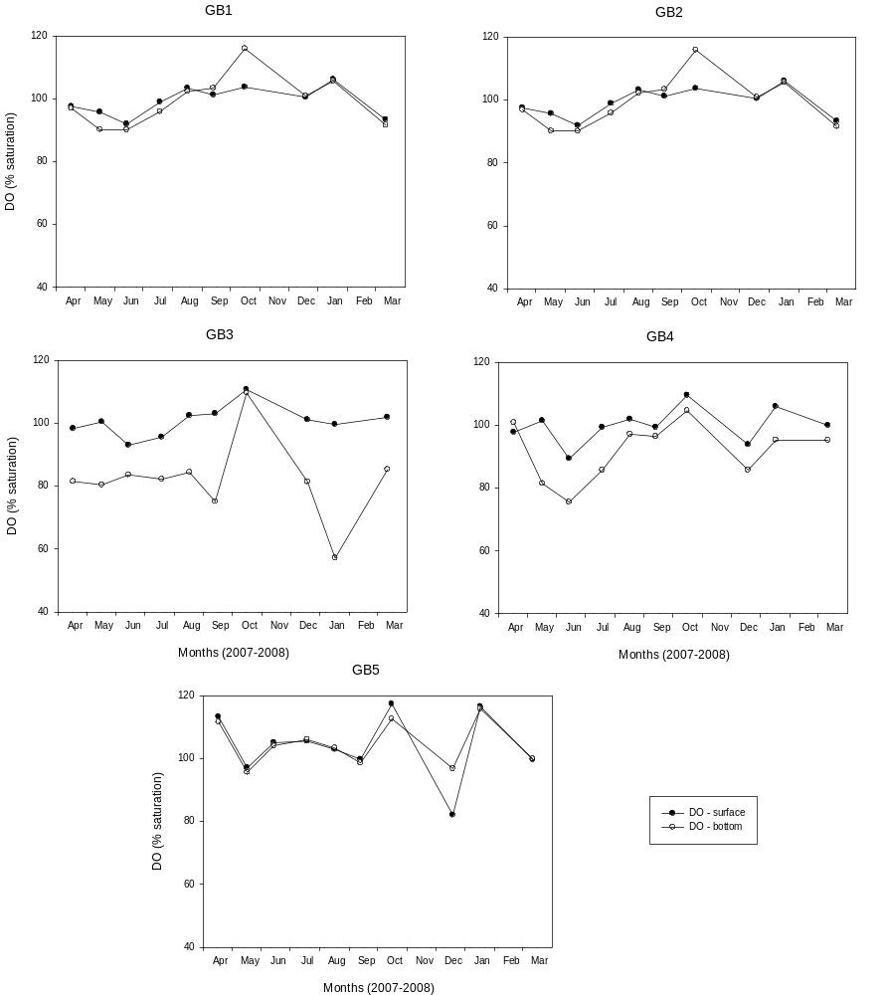
Fig. 6. Dissolved oxygen in surface water at sites in Georges Bay and the river entrance

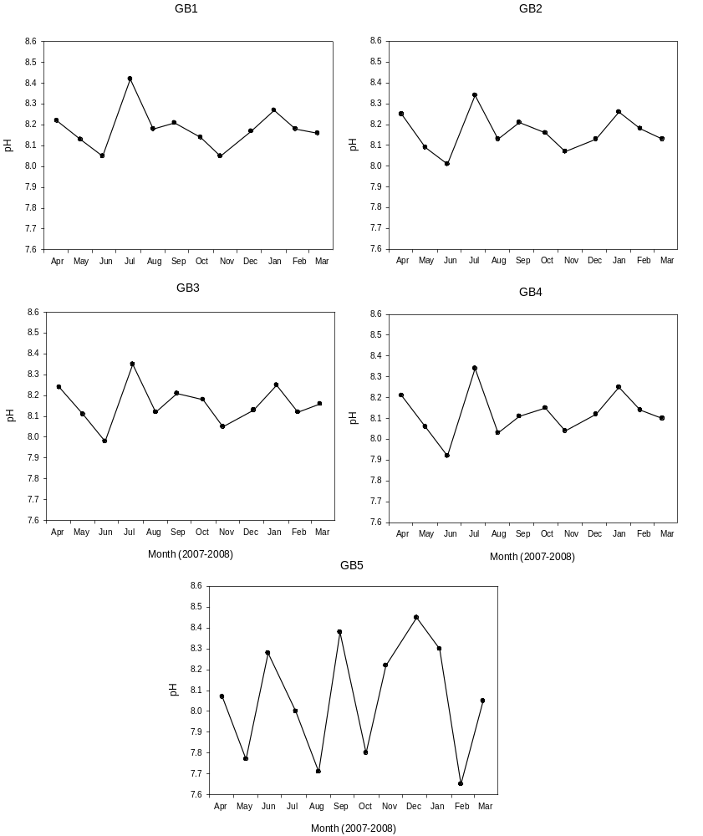

Fig. 7. pH in surface water at sites in Georges Bay and the river entrance

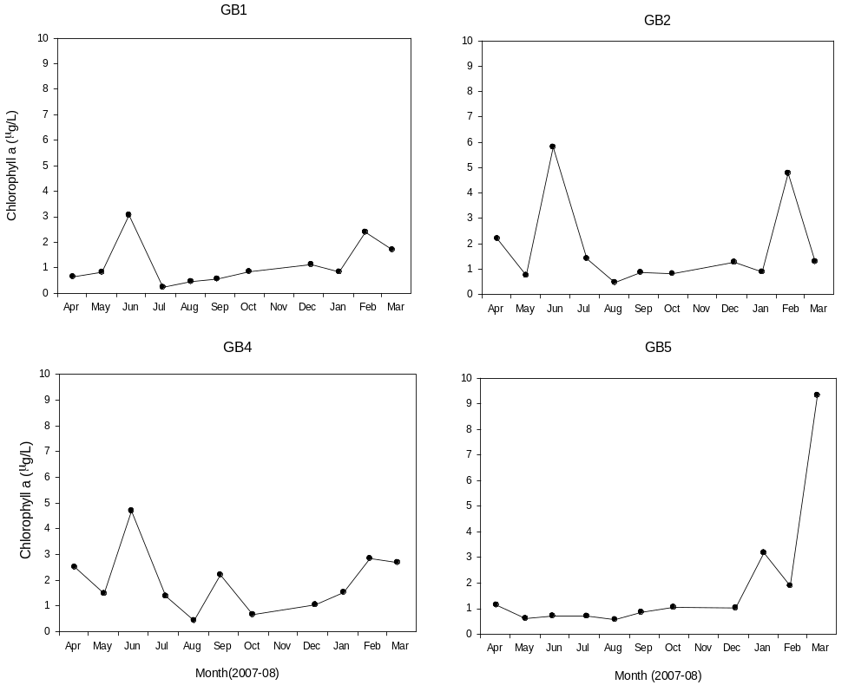
Fig. 8. Chlorophyll a in surface water at sites in Georges Bay and the river entrance

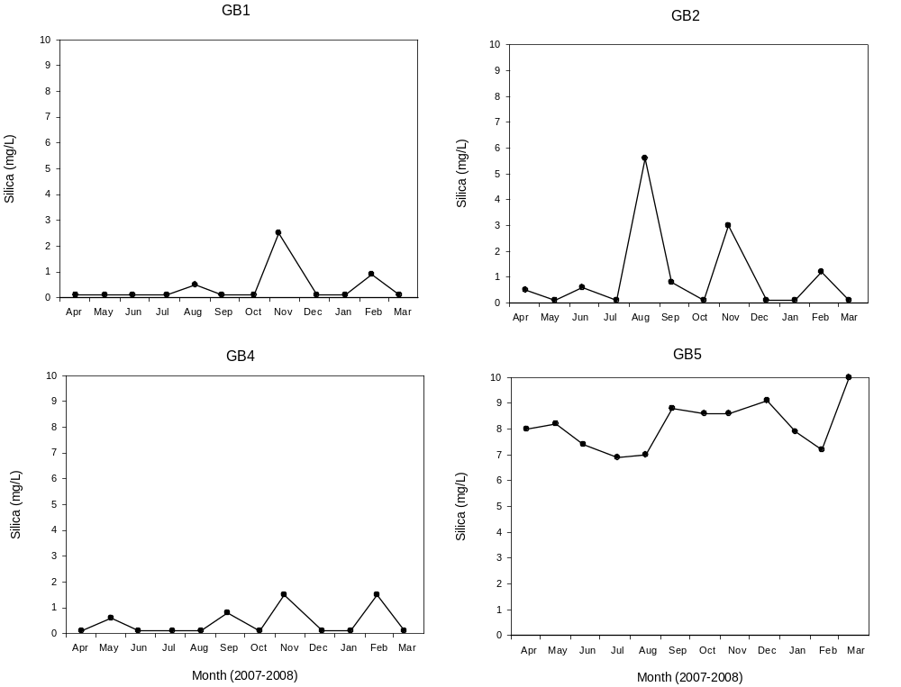
Fig. 9. Silicate concentrations in surface waters at sites in Georges Bay and river entrance.
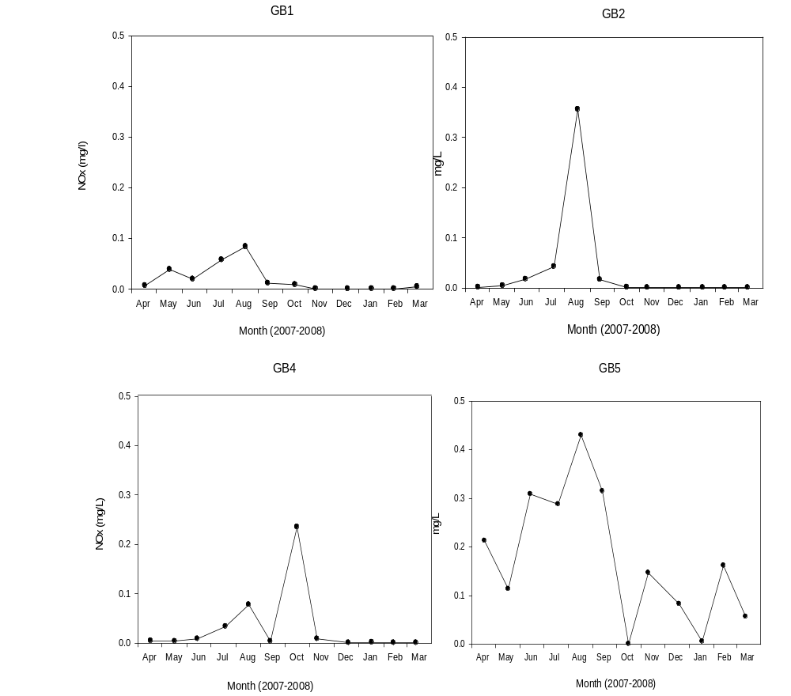

Fig. 10. NOx (nitrate and nitrite) concentrations at sites in Georges Bay and at the river entrance.
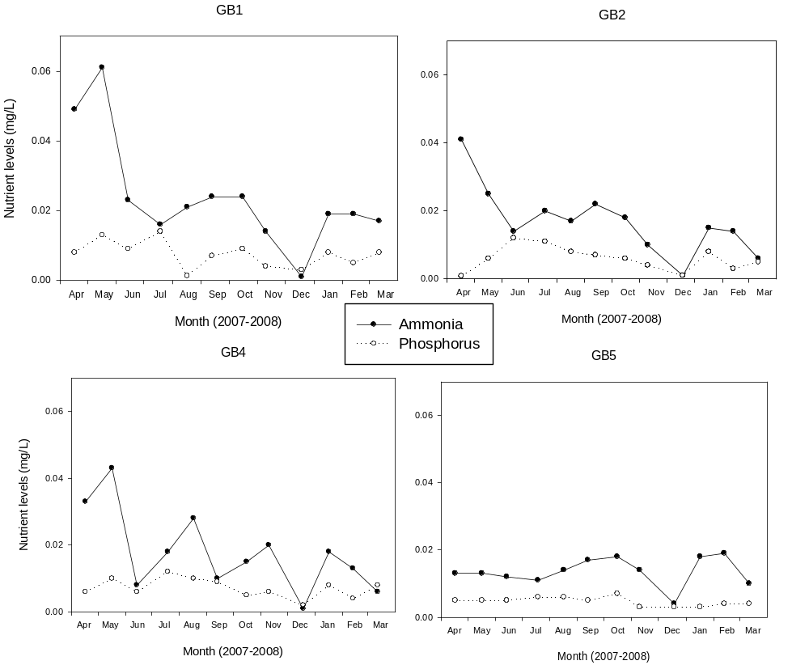

Fig. 11. Ammonia and phosphate concentrations at sites in Georges Bay and at the river entrance.

Macroinvertebrates
A total of 73 species was recorded in these surveys. The sites were all reasonably distinct in terms of invertebrate composition (Fig. 12) with all four sites separating out across the plot, except for some overlap of GB2 and GB4 in January 2008.

Species richness was considerably higher at GB1 in summer than any other site or season (Fig. 13, Table 5). A diverse array of mainly coastal and marine species, dominated by crustaceans (ostracods, cumacean Cyclapsis sp., nebalid Levienebalia sp., amphipods: Parawaldeckia sp. Tomituka doowi and Phoxocephalids) was recorded. A large change in species number and abundance in such a short period of time is unusual but would appear to be due to natural variation as the fauna are indicative of a healthy community. The presence of the generally epiphytal amphipod Cymadusa sp. indicates the presence of seagrass or other epiphytes at this site. No introduced species were present.

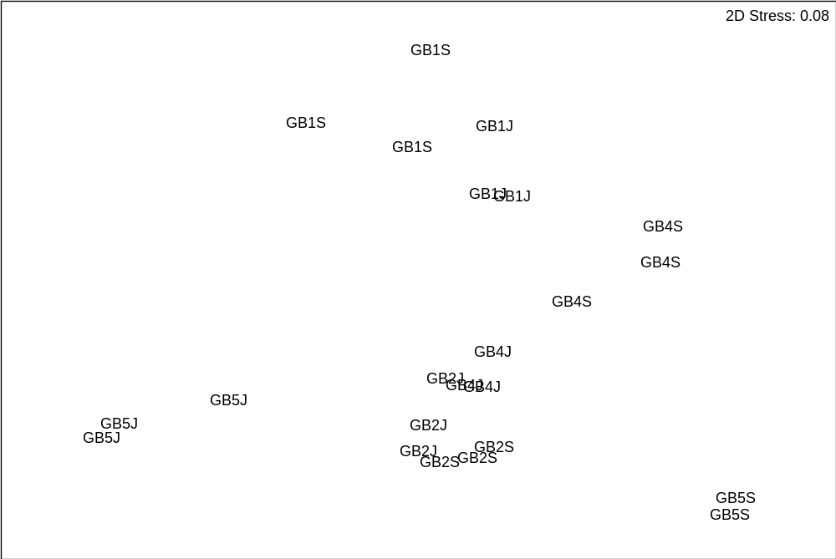

Fig 12. MDS plot of invertebrates at sites GB1, GB2, GB4 and GB5 in September 2007 (S) and January 2008 (J).

Table 1. Species richness and abundance at sites in Georges Bay and the river mouth. n = number of samples, se = standard error.

Season | Site | n | Species Number | se | No. individuals | se
winter | GB1 | 3 | 11 | 3.7 | 38 | 18.7
 | GB2 | 3 | 7.3 | 2.1 | 64.3 | 17.3
 | GB4 | 3 | 15.3 | 1.2 | 126 | 26.9
 | GB5 | 3 | 0.7 | 0.5 | 1 | 0.8
summer | GB1 | 3 | 25.3 | 0.8 | 245 | 43.6
 | GB2 | 3 | 12.3 | 2.5 | 97.3 | 37.2
 | GB4 | 3 | 13.7 | 3.4 | 77.7 | 18.8
 | GB5 | 3 | 2 | 0 | 119 | 105.7

Site GB2 was dominated by deposit-feeding maldanids (bamboo worms), polychaetes Asychis and Clymenella sp., often in densities > 100/grab. This is likely to be a natural situation, particularly where there is sufficient food to support such populations. Introduced bivalve species Corbula gibba was recorded in one grab in January 2008.

Three introduced bivalve species Musculista senhousia, Theora fragilis and Corbula gibba were recorded at site GB4, implying some level of human impact. M. senhousia and T. fragilis occurred at high densities, wheras Corbula was present at much lower densities. Nevertheless, this site supported a reasonably diverse array of benthic species. However, given the densities of the introduced bivalves, it is likely that these species are displacing native species with similar ecological niches.

The fauna at GB5 was impoverished and dominated by Chironomid insect larvae in January 08 (Fig. 14). Spring (September 2007) samples contained few species or individuals. This suggests an impacted site typical of many urban rivers with gravel/cobble substrate.
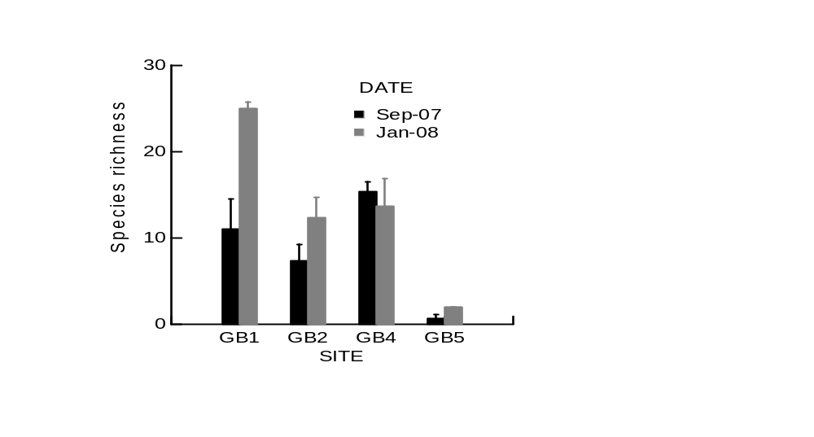
Fig. 13. Species richness at sites in Georges Bay and river mouth.

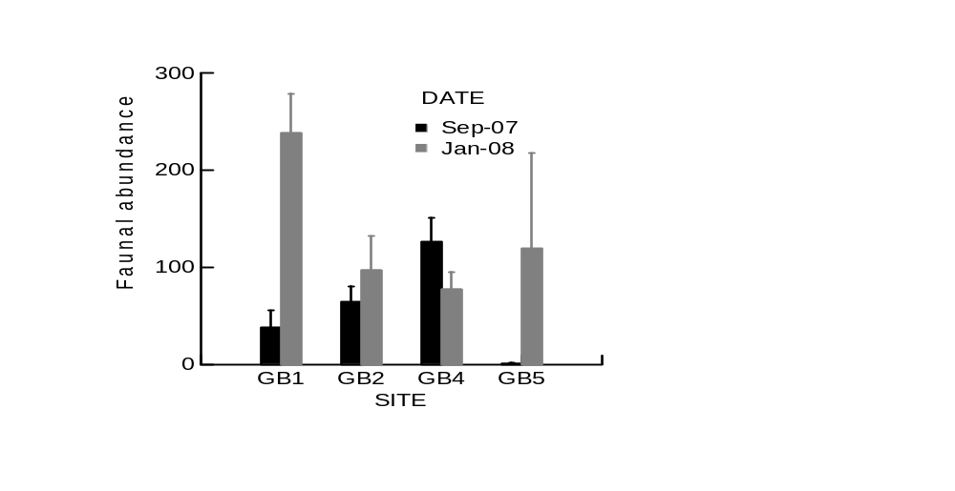
Fig. 14. Abundance of invertebrate species at sites in Georges Bay and the river mouth.

A previous survey in 2000 of macroinvertebrates within and at control sites up to 100m beyond a shellfish farm in Moulting Bay, approximately 750m north of GB4 by Crawford et al (2003) recorded a total of 36 species, half that recorded in the present survey. However, direct comparisons of species richness and total abundance between the two assessments are not relevant because different sampling techniques were used, cores (Crawford et al 2003) and grabs in the present study. These results were compared with shellfish leases in other Tasmanian estuaries and Moulting Bay contained significantly fewer species and lowest number of individuals per samples than the other shellfish farm sites at Dover and Eaglehawk Neck (Crawford et al 2003). This was thought to be due to the high level of very fine sediments, silts and clays, in Moulting Bay compared to the other shellfish farm sites.

Introduced species were much less common at the marine farm sites in 2000 than at GB4 in 2007/08. In 2000 the native bivalve Theora lubrica was common whereas in this study the introduced Theora fragilis was present in relatively high abundance at GB4.

Pathogens

Data from the Tasmanian Shellfish Quality Assurance Program from 6 March 2007 to 29 February 2008 for thermo-tolerant coliforms per 100 ml, indicate relatively low levels of pathogens. Of the 195 measurements taken during the sampling period, only 3% were > 50 thermo-coliforms per 100ml and 6% were >21 thermo- coliforms per 100ml. The majority of these higher levels were recorded near the sewage treatment plant or at the entrance of the river into the bay.

The Moulting Bay area was periodically sampled for toxic algae and biotoxins in shellfish in 2007. No toxic algal species occurred in significant numbers in the few samples analysed and no biotoxins were detected in shellfish above the regulatory limits.

Conclusions

A summary of results, using the list of indicators recommended for monitoring estuaries in Tasmania (Mount 2006), is provided in Table 6.

Table 6. Results of monitoring indicators of estuarine health in 2004/05 and 2007/08

Basic measures of ecosystem  condition | July 04 – June 05 | April 07 – March 08
Temperature | normal | normal
Salinity | normal | normal
Dissolved oxygen  (especially bottom waters) | no data, BOD above guide  lines at sewage outfall | Generally normal, ex below 60%  at Medusa Cove Jan 08
Turbidity | Limited data | Mostly low, ex medium  peaks after flood
Chlorophyll-a | Not monitored | Low-medium, ex peaks in Jun 07 in  bay & Mar 08 at bridge
Habitat extent | Monitored 2005  Available SeaMap Tas website | Not monitored
Important indicators
Animal and plant species  abundance | Not monitored | Lower estuary normal, upper estuary  signs of impact, incl. introduced  species, bridge impacted.
Shoreline position | Not monitored | Being established
Nutrients in the water | NOx - few high values especially Bridge site, NH4 - mostly low, no PO4 data | NO_{x} in bay low over summer, high  peaks in winter, Bridge site regularly  high. PO₄, NH₄ normal for Tas.  Estuaries.
Toxicants | No chemicals above detectable limits in water or oyster meat samples | Not monitored
Pathogens | Low in estuary, high at Bridge site | low % of samples with high  thermotolerant coliforms
pH | Limited data, mostly within limits except ex at sewage outfall | Normal, within 7.0-8.5
Community monitoring
Algal blooms | Not monitored | None recorded
Mass mortalities | Ongoing low level oyster mortalities, no mortalities of native species | None recorded
Litter | Not monitored | Not monitored
Invasive species |  | Not directly monitored

Acknowledgement

We are extremely grateful to Craig Lockwood and staff from Moulting Bay Pacific Oysters Ptd Ltd for providing a boat and driver to undertake the monthly monitoring in the bay. We would also like to thank the community volunteers who assisted in collecting the baseline data. The strong support from Break O’day Council for this project is acknowledged. In particular, Kate Thorne provided administrative support and Brendan Muellers coordinated the community volunteers and provided technical assistance.

References

Crawford, C. 2006. Indicators for Monitoring the Condition of Estuaries and Coastal Waters. Internal Report, Tasmanian Aquaculture and Fisheries Institute, Hobart, Tasmania. Available at: http://eprints.utas.edu.au/view/authors/Crawford,_CM.html

Crawford, C. & Mitchell, I. (1999) Physical and chemical parameters of several oyster growing areas in Tasmania. Technical Report Series. Marine Research Laboratories – Tasmanian Aquaculture & Fisheries Institute, University of Tasmania.

Crawford CM, Macleod C, M., M., Mitchell IM. 2003. Effects of shellfish farming on the benthic environment. Aquaculture 224: 127-140.

Crawford, C and White, CA, 2005 Establishment of an Integrated Water Quality Monitoring Framework for Georges Bay. Report to Break O'Day Council/NRM North. Available at: http://eprints.utas.edu.au/view/authors/Crawford,_CM.html

Crawford, C and Cahill, K. 2007. Manual for the Assessment of the Health of Georges Bay: Community Monitoring. Internal Report, Tasmanian Aquaculture and Fisheries Institute.

DAFF 2007. National Investigation and Reporting Protocol for Fish Kills. Commonwealth of Australia, Canberra. 13 pp.

Mount, RE, Carr, E, Dowson, G, Gales, R, Morris, A, Middleton, N, Crawford, C, Butler, E, Thompson, PA, Shields, D, Hunter, J, Eriksen, R. 2006, 'Tasmanian NRM Estuarine, Coastal and Marine Resource Condition Indicator Compendium', National Land and Water Resource Audit, Version 1.

Murphy, R.J., Crawford, C.M. & Barmuta, L. 2003. Estuarine health in Tasmania, status and indicators: Water Quality. Technical Report Series No 16. Marine Research Laboratories – Tasmanian Aquaculture & Fisheries Institute, University of Tasmania.

Quinn, G P and Keogh M J 2002. Experimental Design and Data Analysis for Biologists. Cambridge University Press, Cambridge UK.

Sinclair Knight Merz (2005) St Helens Wastewater Treatment Plant Upgrade. Break O’Day Council, St Helens.

Appendix A. Invertebrate species collected in three replicates from four sites in Georges Bay. Data are for samples collected in September 2007 and January 2008.

Site |  |  | GB1 | GB1 | GB1 | GB2 | GB2 | GB2 | GB4 | GB4 | GB4 | GB5 | GB5 | GB5
Replicate |  |  | 1 | 2 | 3 | 1 | 2 | 3 | 1 | 2 | 3 | 1 | 2 | 3
Date |  |  | Sep-07 | Sep-07 | Sep-07 | Sep-07 | Sep-07 | Sep-07 | Sep-07 | Sep-07 | Sep-07 | Sep-07 | Sep-07 | Sep-07
Taxonomic name | Family | Class/type
Aricidea pacifica | Paraonidae | Polychaete | 0 | 0 | 0 | 0 | 0 | 0 | 0 | 1 | 2 | 0 | 0 | 0
Armandia sp. MOV 282 | Ophellidae | Polychaete | 0 | 1 | 0 | 0 | 0 | 0 | 0 | 0 | 0 | 0 | 0 | 0
Asychis sp. | Maldanidae | Polychaete | 0 | 0 | 0 | 73 | 34 | 47 | 5 | 0 | 0 | 0 | 0 | 0
Biffarius spp. | Callinassidae | Crustacean | 0 | 0 | 0 | 0 | 1 | 0 | 0 | 0 | 0 | 0 | 0 | 0
Bivalve sp. A |  | Mollusc | 0 | 0 | 1 | 0 | 0 | 0 | 0 | 0 | 0 | 0 | 0 | 0
Ophiuroidea unid. |  | Echinoderm | 0 | 0 | 0 | 0 | 0 | 0 | 5 | 0 | 0 | 0 | 0 | 0
Capitella sp. | Capitellidae | Polychaete | 0 | 1 | 2 | 0 | 0 | 0 | 0 | 0 | 0 | 0 | 0 | 0
Caprellid amphipods unid. | Caprellidae | Crustacean | 0 | 0 | 0 | 0 | 0 | 0 | 9 | 11 | 33 | 0 | 0 | 0
Chaetozone sp. | Cirratulidae | Polychaete | 0 | 0 | 1 | 0 | 0 | 0 | 0 | 0 | 0 | 0 | 0 | 0
Chironomidae unid. |  | Insecta | 0 | 0 | 0 | 0 | 0 | 0 | 0 | 0 | 0 | 0 | 0 | 0
Clymenella sp. | Maldanidae | Polychaete | 0 | 0 | 0 | 0 | 0 | 0 | 0 | 0 | 0 | 0 | 0 | 0
Corbula gibba* |  | Mollusc | 0 | 0 | 0 | 0 | 0 | 0 | 0 | 4 | 0 | 0 | 0 | 0
Corophium sp. | Corophiodea | Crustacean | 0 | 0 | 0 | 0 | 0 | 0 | 0 | 0 | 0 | 0 | 0 | 0
Cymadusa sp. | Ampithoidae | Crustacean | 0 | 0 | 0 | 0 | 0 | 0 | 0 | 0 | 0 | 0 | 0 | 0
Cyclapsis sp. (Cumacean A) |  | Crustacean | 0 | 0 | 0 | 0 | 0 | 0 | 0 | 0 | 0 | 0 | 0 | 0
Palaemon intermedius |  | Crustacean | 0 | 0 | 0 | 0 | 0 | 0 | 0 | 0 | 1 | 0 | 0 | 0
Dexaminidae unid. | Dexaminidae | Crustacean | 0 | 0 | 0 | 2 | 1 | 0 | 1 | 4 | 0 | 0 | 2 | 1
Diplocirrus sp. | Flabelligeridae | Polychaete | 0 | 0 | 0 | 0 | 2 | 0 | 6 | 2 | 0 | 0 | 0 | 0
Echinocardium cordatum |  | Echinoderm | 0 | 0 | 0 | 0 | 0 | 0 | 0 | 0 | 0 | 0 | 0 | 0
Edwardsia sp. |  | Cnidaria | 0 | 0 | 0 | 0 | 0 | 0 | 0 | 0 | 0 | 0 | 0 | 0
Eunice sp. | Eunicidae | Polychaete | 0 | 0 | 0 | 0 | 0 | 0 | 1 | 1 | 0 | 0 | 0 | 0
Eupolymnia sp. | Terebellidae | Polychaete | 0 | 0 | 0 | 0 | 0 | 0 | 0 | 0 | 0 | 0 | 0 | 0
Felaniella globularis |  | Mollusc | 0 | 0 | 0 | 0 | 0 | 0 | 0 | 0 | 0 | 0 | 0 | 0
Gammaropsis sp. | Corophiodea | Crustacean | 0 | 0 | 0 | 0 | 0 | 0 | 0 | 0 | 0 | 0 | 0 | 0
Glycera sp. | Glyceridae | Polychaete | 0 | 0 | 0 | 0 | 0 | 0 | 0 | 0 | 0 | 0 | 0 | 0
Paragraspus gaimardii | Grapsidae | Crustacean | 0 | 0 | 0 | 0 | 0 | 0 | 0 | 1 | 0 | 0 | 0 | 0
Halicarcinus rostratus | Hymenosomatidae | Crustacean | 0 | 3 | 0 | 0 | 0 | 0 | 2 | 1 | 1 | 0 | 0 | 0
Halicacinus ovatus | Hymenosomatidae | Crustacean | 0 | 0 | 0 | 1 | 0 | 0 | 0 | 0 | 0 | 0 | 0 | 0
Hesionidae unid. | Hesionidae | Polychaete | 0 | 0 | 0 | 1 | 2 | 0 | 0 | 0 | 0 | 0 | 0 | 0
Hirsutonuphis macrocerata |  | Polychaete | 0 | 0 | 0 | 0 | 0 | 0 | 0 | 0 | 0 | 0 | 0 | 0
Katelysia sp. |  | Mollusc | 0 | 0 | 1 | 0 | 0 | 0 | 0 | 1 | 0 | 0 | 0 | 0
Lumbrineridae sp. | Lumbrineridae | Polychaete | 1 | 0 | 2 | 0 | 0 | 0 | 0 | 0 | 0 | 0 | 0 | 0
Lanternula sp. |  | Mollusc | 0 | 0 | 0 | 0 | 0 | 0 | 0 | 0 | 0 | 0 | 0 | 0
Liljeborgia sp. | Liljeboridae | Crustacean | 0 | 0 | 0 | 0 | 0 | 0 | 0 | 0 | 0 | 0 | 0 | 0
Lysarete sp.? |  | Polychaete | 0 | 0 | 0 | 0 | 0 | 0 | 0 | 0 | 0 | 0 | 0 | 0
Parawaldeckia sp. | Lysianassidae | Crustacean | 0 | 1 | 2 | 0 | 0 | 0 | 0 | 0 | 0 | 0 | 0 | 0
Microspio granulata | Spionidae | Polychaete | 0 | 0 | 1 | 0 | 0 | 0 | 0 | 0 | 0 | 0 | 0 | 0
Musculista senhousia* |  | Mollusc | 0 | 0 | 0 | 0 | 0 | 0 | 2 | 71 | 29 | 0 | 0 | 0
Mysella donaciformis |  | Mollusc | 1 | 0 | 0 | 0 | 0 | 0 | 0 | 0 | 0 | 0 | 0 | 0
Nassarius pauperatus |  | Mollusc | 0 | 7 | 2 | 0 | 0 | 0 | 0 | 0 | 0 | 0 | 0 | 0
Neanthes biseriata | Nereididae | Polychaete | 0 | 2 | 1 | 0 | 0 | 0 | 0 | 0 | 0 | 0 | 0 | 0
Levinebalia sp. | Paranebalidae | Crustacean | 0 | 0 | 0 | 0 | 0 | 0 | 0 | 0 | 0 | 0 | 0 | 0
Nemertean unid. |  |  | 1 | 4 | 0 | 1 | 0 | 0 | 0 | 0 | 1 | 0 | 0 | 0
Nephtys australieneis | Nephytidae | Polychaete | 0 | 0 | 0 | 2 | 2 | 2 | 0 | 0 | 0 | 0 | 0 | 0
Oligochaeta unid. |  | Oligochaete | 0 | 0 | 0 | 0 | 0 | 0 | 0 | 0 | 0 | 0 | 0 | 0
Ostracod sp. A |  | Crustacean | 1 | 11 | 18 | 0 | 0 | 0 | 0 | 0 | 0 | 0 | 0 | 0
Ostracod sp. B |  | Crustacean | 0 | 0 | 4 | 0 | 0 | 0 | 0 | 0 | 0 | 0 | 0 | 0
Ostracod sp. C |  | Crustacean | 0 | 0 | 1 | 0 | 0 | 0 | 0 | 0 | 0 | 0 | 0 | 0
Paraprionospio sp. | Spionidae | Polychaete | 0 | 0 | 0 | 2 | 3 | 9 | 0 | 0 | 0 | 0 | 0 | 0
Patelloida insignis |  | Mollusc | 0 | 0 | 0 | 0 | 0 | 0 | 0 | 0 | 0 | 0 | 0 | 0
Pectinaria antipoda | Pectinariidae | Polychaete | 0 | 0 | 0 | 0 | 0 | 2 | 0 | 0 | 0 | 0 | 0 | 0
Photis sp. |  | Crustacean | 0 | 0 | 0 | 1 | 0 | 0 | 0 | 0 | 0 | 0 | 0 | 0
Phoxocephalidae unid. |  | Crustacean | 11 | 2 | 18 | 0 | 0 | 0 | 1 | 0 | 0 | 0 | 0 | 0
Phyllodoe sp. A | Phyllodocidae | Polychaete | 0 | 0 | 1 | 0 | 0 | 0 | 0 | 1 | 2 | 0 | 0 | 0
Phyllodoe sp. B | Phyllodocidae | Polychaete | 0 | 0 | 0 | 0 | 0 | 0 | 0 | 0 | 0 | 0 | 0 | 0
Pista australis | Terebellidae | Polychaete | 0 | 0 | 0 | 0 | 0 | 0 | 0 | 3 | 0 | 0 | 0 | 0
Polynoidae unid. | Polynoidae | Polychaete | 0 | 0 | 0 | 0 | 0 | 0 | 0 | 6 | 4 | 0 | 0 | 0
Sabellastarte sp. | Sabellidae | Polychaete | 0 | 0 | 0 | 0 | 0 | 0 | 1 | 0 | 0 | 0 | 0 | 0
Scoloplos normalis | Orbiniidae | Polychaete | 1 | 0 | 0 | 0 | 0 | 0 | 0 | 0 | 0 | 0 | 0 | 0
Scoloplos simplex | Orbiniidae | Polychaete | 0 | 0 | 0 | 1 | 0 | 1 | 0 | 0 | 0 | 0 | 0 | 0
Serpula sp. | Serpulidae | Polychaete | 0 | 0 | 0 | 0 | 0 | 0 | 0 | 0 | 1 | 0 | 0 | 0
Sigalionidae unid. |  | Polychaete | 0 | 0 | 0 | 0 | 0 | 0 | 0 | 0 | 0 | 0 | 0 | 0
Simplisetia aequisetis | Nereididae | Polychaete | 0 | 0 | 0 | 0 | 0 | 0 | 8 | 4 | 0 | 0 | 0 | 0
Solemya australis |  | Mollusc | 0 | 0 | 7 | 0 | 0 | 0 | 0 | 0 | 0 | 0 | 0 | 0
Tanaid sp. A |  | Crustacean | 0 | 1 | 0 | 0 | 0 | 0 | 3 | 8 | 10 | 0 | 0 | 0
Tanaid sp. B |  | Crustacean | 0 | 0 | 0 | 3 | 0 | 0 | 0 | 0 | 0 | 0 | 0 | 0
Tanaid sp. C |  | Crustacean | 0 | 0 | 0 | 0 | 0 | 0 | 2 | 0 | 1 | 0 | 0 | 0
Theora fragilis* |  | Mollusc | 0 | 0 | 0 | 0 | 0 | 0 | 51 | 43 | 25 | 0 | 0 | 0
Terebella sp. | Terebellidae | Polychaete | 0 | 0 | 0 | 0 | 0 | 0 | 0 | 0 | 0 | 0 | 0 | 0
Terebellides sp. | Trichobranchidae | Polychaete | 0 | 0 | 0 | 0 | 0 | 0 | 3 | 1 | 1 | 0 | 0 | 0
Tethygeneia sp. | Eusiridae | Crustacean | 0 | 0 | 0 | 0 | 0 | 0 | 0 | 0 | 0 | 0 | 0 | 0
Tomituka doowi | Platyischnopus | Crustacean | 2 | 0 | 1 | 0 | 0 | 0 | 0 | 0 | 0 | 0 | 0 | 0
Venerupis sp. |  | Mollusc | 0 | 0 | 0 | 0 | 0 | 0 | 0 | 0 | 4 | 0 | 0 | 0
* introduced species

Site |  |  | GB1 | GB1 | GB1 | GB2 | GB2 | GB2 | GB4 | GB4 | GB4 | GB5 | GB5 | GB5
Replicate |  |  | 1 | 2 | 3 | 1 | 2 | 3 | 1 | 2 | 3 | 1 | 2 | 3
Date |  |  | Jan-08 | Jan-08 | Jan-08 | Jan-08 | Jan-08 | Jan-08 | Jan-08 | Jan-08 | Jan-08 | Jan-08 | Jan-08 | Jan-08
Taxonomic name | Family | Class/type
Aricidea pacifica | Paraonidae | Polychaete | 0 | 0 | 0 | 0 | 0 | 0 | 0 | 0 | 0 | 0 | 0 | 0
Armandia sp. MOV 282 | Ophellidae | Polychaete | 7 | 3 | 0 | 0 | 0 | 0 | 0 | 0 | 0 | 0 | 0 | 0
Asychis sp. | Maldanidae | Polychaete | 0 | 3 | 1 | 51 | 97 | 19 | 31 | 23 | 39 | 0 | 3 | 0
Biffarius spp. | Callinassidae | Crustacean | 0 | 0 | 0 | 0 | 1 | 1 | 0 | 0 | 0 | 0 | 0 | 0
Bivalve sp. A |  | Mollusc | 0 | 0 | 0 | 0 | 0 | 0 | 0 | 0 | 0 | 0 | 0 | 0
Ophiuroidea unid. |  | Echinoderm | 1 | 4 | 0 | 0 | 0 | 0 | 6 | 6 | 7 | 0 | 0 | 0
Capitella sp. | Capitellidae | Polychaete | 2 | 6 | 0 | 0 | 0 | 0 | 0 | 0 | 0 | 0 | 0 | 0
Caprellid amphipods unid. | Caprellidae | Crustacean | 0 | 0 | 3 | 0 | 0 | 0 | 0 | 0 | 0 | 0 | 0 | 0
Chaetozone sp. | Cirratulidae | Polychaete | 0 | 0 | 0 | 0 | 0 | 0 | 0 | 0 | 0 | 0 | 0 | 0
Chironomidae unid. |  | Insecta | 0 | 0 | 0 | 0 | 0 | 0 | 0 | 0 | 0 | 20 | 263 | 67
Clymenella sp. | Maldanidae | Polychaete | 0 | 0 | 0 | 11 | 9 | 3 | 0 | 0 | 0 | 0 | 0 | 0
Corbula gibba* |  | Mollusc | 0 | 0 | 0 | 0 | 0 | 4 | 0 | 1 | 1 | 0 | 0 | 0
Corophium sp. | Corophiodea | Crustacean | 0 | 0 | 0 | 0 | 0 | 0 | 1 | 0 | 0 | 0 | 0 | 0
Cymadusa sp. | Ampithoidae | Crustacean | 4 | 8 | 2 | 0 | 0 | 0 | 0 | 0 | 0 | 0 | 0 | 0
Cyclapsis sp. (Cumacean A) |  | Crustacean | 14 | 2 | 4 | 0 | 0 | 0 | 0 | 0 | 0 | 0 | 0 | 0
Palaemon intermedius |  | Crustacean | 0 | 0 | 0 | 0 | 0 | 0 | 0 | 0 | 0 | 0 | 0 | 0
Dexaminidae unid. | Dexaminidae | Crustacean | 0 | 1 | 4 | 0 | 0 | 0 | 0 | 0 | 1 | 0 | 0 | 0
Diplocirrus sp. | Flabelligeridae | Polychaete | 0 | 0 | 1 | 1 | 6 | 5 | 5 | 6 | 4 | 0 | 0 | 0
Echinocardium cordatum |  | Echinoderm | 0 | 0 | 0 | 0 | 0 | 0 | 1 | 0 | 0 | 0 | 0 | 0
Edwardsia sp. |  | Cnidaria | 0 | 1 | 0 | 0 | 0 | 0 | 0 | 1 | 0 | 0 | 0 | 0
Eunice sp. | Eunicidae | Polychaete | 0 | 0 | 0 | 0 | 0 | 0 | 0 | 0 | 0 | 0 | 0 | 0
Eupolymnia sp. | Terebellidae | Polychaete | 1 | 3 | 0 | 1 | 0 | 0 | 0 | 0 | 0 | 0 | 0 | 0
Felaniella globularis |  | Mollusc | 1 | 0 | 0 | 0 | 0 | 0 | 0 | 0 | 0 | 0 | 0 | 0
Gammaropsis sp. | Corophiodea | Crustacean | 0 | 0 | 0 | 0 | 0 | 2 | 0 | 0 | 0 | 0 | 0 | 0
Glycera sp. | Glyceridae | Polychaete | 0 | 0 | 0 | 0 | 1 | 0 | 0 | 0 | 1 | 0 | 0 | 0
Paragraspus gaimardii | Grapsidae | Crustacean | 0 | 0 | 0 | 0 | 0 | 0 | 0 | 0 | 0 | 0 | 0 | 0
Halicarcinus rostratus | Hymenosomatidae | Crustacean | 0 | 2 | 1 | 0 | 1 | 1 | 2 | 0 | 1 | 0 | 0 | 0
Halicacinus ovatus | Hymenosomatidae | Crustacean | 0 | 3 | 2 | 0 | 0 | 0 | 0 | 0 | 0 | 0 | 0 | 0
Hesionidae unid. | Hesionidae | Polychaete | 1 | 2 | 0 | 0 | 5 | 2 | 0 | 0 | 0 | 0 | 0 | 0
Hirsutonuphis macrocerata |  | Polychaete | 1 | 0 | 0 | 0 | 0 | 0 | 0 | 0 | 0 | 0 | 0 | 0
Katelysia sp. |  | Mollusc | 0 | 0 | 0 | 0 | 0 | 0 | 0 | 0 | 0 | 0 | 0 | 0
Lumbrineridae sp. | Lumbrineridae | Polychaete | 2 | 0 | 2 | 0 | 0 | 0 | 0 | 0 | 0 | 0 | 0 | 0
Lanternula sp. |  | Mollusc | 0 | 0 | 0 | 2 | 2 | 7 | 0 | 0 | 1 | 0 | 0 | 0
Liljeborgia sp. | Liljeboridae | Crustacean | 0 | 0 | 0 | 1 | 0 | 0 | 1 | 0 | 1 | 0 | 0 | 0
Lysarete sp.? |  | Polychaete | 0 | 1 | 1 | 0 | 0 | 0 | 0 | 0 | 0 | 0 | 0 | 0
Parawaldeckia sp. | Lysianassidae | Crustacean | 51 | 17 | 20 | 0 | 0 | 0 | 0 | 0 | 0 | 0 | 0 | 0
Microspio granulata | Spionidae | Polychaete | 0 | 0 | 0 | 0 | 0 | 0 | 0 | 0 | 0 | 0 | 0 | 0
Musculista senhousia* |  | Mollusc | 0 | 0 | 0 | 0 | 0 | 0 | 0 | 0 | 0 | 0 | 0 | 0
Mysella donaciformis |  | Mollusc | 0 | 0 | 0 | 0 | 0 | 0 | 0 | 0 | 0 | 0 | 0 | 0
Nassarius pauperatus |  | Mollusc | 5 | 8 | 13 | 0 | 0 | 0 | 1 | 0 | 0 | 0 | 0 | 0
Neanthes biseriata | Nereididae | Polychaete | 2 | 2 | 1 | 0 | 0 | 0 | 0 | 0 | 0 | 0 | 0 | 0
Levinebalia sp. | Paranebalidae | Crustacean | 7 | 16 | 18 | 0 | 0 | 0 | 0 | 0 | 0 | 0 | 0 | 0
Nemertean unid. |  |  | 4 | 1 | 0 | 0 | 0 | 5 | 0 | 5 | 9 | 0 | 0 | 0
Nephtys australieneis | Nephytidae | Polychaete | 0 | 0 | 1 | 1 | 8 | 4 | 1 | 4 | 7 | 0 | 0 | 0
Oligochaeta unid. |  | Oligochaete | 0 | 0 | 0 | 0 | 0 | 0 | 0 | 0 | 0 | 2 | 0 | 2
Ostracod sp. A |  | Crustacean | 68 | 62 | 113 | 0 | 0 | 0 | 0 | 0 | 0 | 0 | 0 | 0
Ostracod sp. B |  | Crustacean | 75 | 0 | 0 | 0 | 0 | 0 | 0 | 0 | 0 | 0 | 0 | 0
Ostracod sp. C |  | Crustacean | 0 | 0 | 28 | 0 | 0 | 0 | 0 | 0 | 0 | 0 | 0 | 0
Paraprionospio sp. | Spionidae | Polychaete | 0 | 0 | 0 | 3 | 9 | 9 | 4 | 8 | 5 | 0 | 0 | 0
Patelloida insignis |  | Mollusc | 0 | 1 | 0 | 0 | 0 | 0 | 0 | 0 | 0 | 0 | 0 | 0
Pectinaria antipoda | Pectinariidae | Polychaete | 0 | 0 | 0 | 1 | 7 | 5 | 1 | 0 | 9 | 0 | 0 | 0
Photis sp. |  | Crustacean | 0 | 0 | 0 | 0 | 0 | 0 | 0 | 0 | 2 | 0 | 0 | 0
Phoxocephalidae unid. |  | Crustacean | 22 | 31 | 29 | 0 | 0 | 0 | 0 | 0 | 0 | 0 | 0 | 0
Phyllodoe sp. A | Phyllodocidae | Polychaete | 0 | 0 | 0 | 0 | 0 | 0 | 0 | 0 | 0 | 0 | 0 | 0
Phyllodoe sp. B | Phyllodocidae | Polychaete | 1 | 0 | 0 | 0 | 0 | 0 | 0 | 0 | 0 | 0 | 0 | 0
Pista australis | Terebellidae | Polychaete | 0 | 0 | 0 | 0 | 0 | 0 | 0 | 0 | 0 | 0 | 0 | 0
Polynoidae unid. | Polynoidae | Polychaete | 5 | 2 | 1 | 0 | 0 | 0 | 1 | 0 | 0 | 0 | 0 | 0
Sabellastarte sp. | Sabellidae | Polychaete | 1 | 0 | 0 | 0 | 0 | 0 | 0 | 0 | 0 | 0 | 0 | 0
Scoloplos normalis | Orbiniidae | Polychaete | 0 | 0 | 0 | 0 | 0 | 0 | 0 | 0 | 0 | 0 | 0 | 0
Scoloplos simplex | Orbiniidae | Polychaete | 5 | 0 | 3 | 0 | 1 | 1 | 1 | 0 | 0 | 0 | 0 | 0
Serpula sp. | Serpulidae | Polychaete | 0 | 0 | 0 | 0 | 0 | 0 | 0 | 0 | 0 | 0 | 0 | 0
Sigalionidae unid. |  | Polychaete | 0 | 0 | 0 | 0 | 0 | 0 | 1 | 0 | 0 | 0 | 0 | 0
Simplisetia aequisetis | Nereididae | Polychaete | 0 | 0 | 0 | 0 | 0 | 0 | 0 | 0 | 0 | 0 | 0 | 0
Solemya australis |  | Mollusc | 1 | 2 | 2 | 0 | 0 | 0 | 0 | 0 | 0 | 0 | 0 | 0
Tanaid sp. A |  | Crustacean | 6 | 2 | 3 | 0 | 0 | 2 | 7 | 0 | 0 | 0 | 0 | 0
Tanaid sp. B |  | Crustacean | 0 | 0 | 0 | 0 | 3 | 0 | 0 | 0 | 0 | 0 | 0 | 0
Tanaid sp. C |  | Crustacean | 0 | 0 | 0 | 0 | 0 | 0 | 0 | 0 | 0 | 0 | 0 | 0
Theora fragilis* |  | Mollusc | 0 | 0 | 0 | 0 | 0 | 0 | 7 | 4 | 15 | 0 | 0 | 0
Terebella sp. | Terebellidae | Polychaete | 1 | 1 | 2 | 0 | 0 | 0 | 0 | 0 | 0 | 0 | 0 | 0
Terebellides sp. | Trichobranchidae | Polychaete | 0 | 0 | 0 | 0 | 0 | 0 | 0 | 0 | 0 | 0 | 0 | 0
Tethygeneia sp. | Eusiridae | Crustacean | 0 | 3 | 1 | 0 | 0 | 0 | 0 | 0 | 0 | 0 | 0 | 0
Tomituka doowi | Platyischnopus | Crustacean | 0 | 0 | 0 | 0 | 0 | 0 | 0 | 0 | 0 | 0 | 0 | 0
Venerupis sp. |  | Mollusc | 4 | 0 | 0 | 0 | 0 | 0 | 1 | 0 | 0 | 0 | 0 | 0
* introduced species

Appendix B

Manual for the Assessment of the Health of Georges Bay: Community Monitoring

Manual for the

Assessment of the Health

of Georges Bay:

Community Monitoring

Christine Crawford and Kylie Cahill
July 2007


Assessment of the health of Georges Bay

Disclaimer
The content of this report has been based on existing information that will be subject to change as new information becomes available. Every effort has been made to ensure that the information contained in this report is accurate. The opinions expressed in this report are those of the author/s and are not necessarily those of the Tasmanian Aquaculture and Fisheries Institute.

©Tasmanian Aquaculture and Fisheries Institute, University of Tasmania 2007

Marine Research Laboratories – Tasmanian Aquaculture and Fisheries Institute, University of Tasmania, Private Bag 49, Hobart, Tasmania, 7001.
Email: Christine.Crawford@utas.edu.au
Ph: (03) 6227 7224
Fax: (03) 6227 8035

Contents

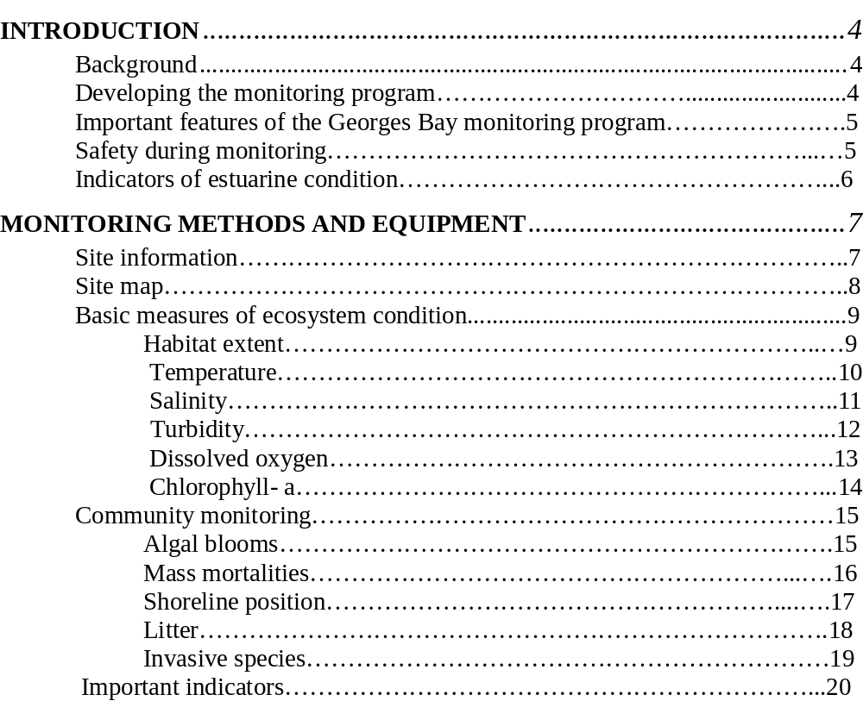
Nutrients in the water column………………………………………..20
pH…………………………………………………………………….21
Animal or plant species abundance…………………………………..22
Toxicants: sediment, water column, biota…………………………....23
Pathogens…………………………………………………………….24

APPENDIX A: Water quality monitoring data sheet……………………………25

APPENDIX B: Mass mortality data record………………………………………26

Introduction
Background

This manual describes a monitoring program for assessment of the health of Georges Bay. It includes indicators of estuarine health that are recommended for monitoring the bay and details of the methods and equipment used to measure these indicators.

The manual follows on from a report on the ’Establishment of an integrated water quality monitoring framework for Georges Bay’ by Crawford and White (2005). In this report the water quality information available for Georges Bay was summarised and a preliminary monitoring program was recommended. A report card for the health of Georges Bay for the twelve months July 2004 to June 2005 was also provided. More general information on the ecology of Georges Bay is available in another report ‘Bringing Back the Bay: Marine Habitats and Water Quality in Georges Bay’ by Mount et al (2005).

The indicators that are recommended for monitoring in Georges Bay are based on those recommended for monitoring estuaries and coastal waters in Tasmania by the Tasmanian Coastal, Estuarine and Marine (CEM) Indicators Working Group. This recommended set of indicators is detailed in The Tasmanian Indicator Compendium, draft form available at: http://www.environment.tas.gov.au/cm_draft_tasmanian_estuarine_coastal_marine_indicators.html. A summarised version of the Tasmanian Indicator Compendium entitled ‘Indicators for the condition of estuaries and coastal waters in Tasmania’ was written by Crawford (2006).

These Tasmanian indicators are a subset of the national indicator set and are those that are considered to be a high priority for monitoring in Tasmania. Information on the national indicator set is available in the Coastal CRC Users Guide: Scheltinga et al (2004). Users’ guide to estuarine, coastal and marine indicators for regional NRM monitoring; available at http://www.coastal.crc.org.au/Publications/Indicators.html . They are also listed on the Australian Government NRM website, available at http://www.nrm.gov.au/publications/factsheets/me-indicators/index.html#ecmhi.

Developing the Monitoring Program

A number of manuals and reports have already been written on developing monitoring programs for estuarine health in Australia. These describe the requirements of monitoring programs and suitable methods and equipment in considerable detail. As a consequence, this manual is purposely short and to the point about methods recommended for assessment of the condition of Georges Bay. For further information about setting up an estuarine monitoring program in Tasmania and other indicators and methods, two reports are recommended:

- Indicators for the condition of estuaries and coastal waters’ by Crawford (2006)
- Waterwatch Australia National Technical Manual Module 7 Estuarine Monitoring (2006).
A recommended general book for identification of estuarine and marine flora and fauna is Australian Marine Life, the plants and animals of temperate waters by Edgar (1997). As the author is Tasmanian, this book contains many photographs of animals and plant found in Tasmanian waters.

Important features of the Georges Bay monitoring program

- The environmental variables recommended for monitoring have been chosen to give an overall picture of the health of Georges Bay. They are not targeted at point sources of pollution.
- It is very important that the same set of environmental variables is monitored at the same sites over time using the same monitoring methods. If sampling is conducted at different sites or using different methods then we would not know whether any change observed is due to a change in environmental condition or because it is at another site or different methodology.
- The environmental variables recommended, which are a combination of water column and biological variables, are considered to be the minimum set for cost-effective assessment of the condition of the bay. There are a number of other variables that could be monitored but it is important that the same minimum set of variables is monitored each time to be able to detect any change in condition.
- The sites recommended for monitoring in Georges Bay have been chosen based on their representativeness of the bay and on the availability of data from that site from previous studies in the bay. Where possible sites have been chosen that have previously been monitored so that comparisons can be made between current and past results.
- Because some estuarine environmental variables vary significantly according to the tides, it is important to monitor at the same stage of the tide each time. Following on from previous monitoring in Georges Bay, monitoring water column variables during the outgoing tide and preferably as close to slack low tide as possible, is recommended.
- Some environmental variables, especially water quality measures, can change dramatically between normal conditions and during floods, therefore sampling during flood events is recommended. The impact of these flood waters on estuarine health is currently poorly understood and more data are required.

Safety during monitoring

Safe monitoring methods are of utmost importance as the estuarine and inshore water environments are renowned for their unpredictability and rapidly changing conditions. Rogue waves, rapidly changing tides, fast changes in sea condition, partially submerged floating objects and sudden changes in water depth are not uncommon in estuaries. Thus it is essential that monitoring in estuaries is never conducted alone and a constant eye is kept on the weather and surrounding conditions. Personal floatation devices must be worn when sampling from a boat or in streams.

Indicators of estuarine condition

The indicators of estuarine condition that have been recommended by the Tasmanian Coastal, Estuarine and Marine (CEM) Indicators Working Group are listed in Table 1. These include some indicators that are readily measured by community people with minimal training whereas others require considerable experience and often external funding. Because there is a wide variety of expertise and financial support amongst community groups and local councils, it is difficult to recommend a standard monitoring program. As a consequence the indicators have been divided into two groups: (i) simple and inexpensive methods suited to any community group and (ii) more complicated methods requiring some expertise and often external funding.

It must be emphasised that the monitoring methods recommended in this manual are those considered to be most appropriate at the time of writing. However, they should be regularly reviewed as more data become available and modified to incorporate new and improved methods.

Table 1. Recommended indicators of the condition of estuaries and coastal waters in Tasmania and their suitability for community or expertise-based monitoring.

Basic measures of ecosystem condition | Community-  based monitoring | Expertise-based monitoring
Temperature | √ | √
Salinity | √ | √
Dissolved oxygen  (especially bottom waters) | √ | √
Turbidity | √ | √
Chlorophyll-a | ? | √
Habitat extent | ? | √
Important indicators
Animal and plant species abundance |  | √
Shoreline position | √ | √
Nutrients in the water column | ? | √
Toxicants |  | √
Pathogens | ? | √
pH | √ | √
Community monitoring
Algal blooms | √ | √
Mass mortalities | √
Litter | √
Invasive species | √ | √

Monitoring methods and equipment

Site information

Five sites have been selected for monitoring based on their representativeness of the bay and on the availability of data at that site from previous studies in the bay. These sites are shown in Fig. 1 and are described in Table 2 below.

It is essential that these sites are monitored each time and not changed for a ‘more interesting’ site nearby. This consistency of sampling the same sites each time is critical to showing any changes if they occur.

At each sampling site it is very important to document background information on each monitoring occasion, including:

- the name of the person conducting the monitoring
- the date and time of day
- state of the tide
- weather conditions
- any notable observations

An example data sheet is provided in Appendix A.

Table 2. Visual references and GPS co-ordinates for Georges Bay monitoring sites

Site | Description | GPS Co-ordinates
GB1 | Green navigation pylon in the centre of the  channel slightly south west of Lords Point | 5426947 N 609946 E
GB2 | At the base of the Yellow Bluff cliffs, level with  the last house on the top of the Stieglizt end of the  bluff approximately 200m off shore | 5424691 N 608014 E
GB3 | An equal distance between the red navigation  pylon and Lowrys Point | 5423922 N 605346 E
GB4 | Approximately 200m off Humbug Point in a  westerly direction, an equal distance between the  point and the northern most yellow corner marker  of the nearby oyster lease | 5426681 N 607836 E
GB5 | In the creek on the western side of Treloggen  Bridge on the Binalong Bay road | 5425683 N 605902 E

Site map

Fig. 1. Map of five water sampling sites in Georges Bay (www.thelist.tas.gov.au)
Basic measures of ecosystem condition

Habitat extent

The health of estuaries and coastal waters depends on the maintenance of a diverse range of habitats. Loss of habitat results in the loss of organisms that need that habitat to survive and thus a decrease in biodiversity.

A detailed map of the subtidal habitats of Georges Bay has already been prepared by Mount et al (2005) from the Tasmanian Aquaculture and Fisheries Institute (Fig. 2). It is recommended that this map is updated every five years to examine whether any changes in habitat are occurring; for example a change in the size and area of seagrass beds or sand/silt sediments.

Community mapping of the distribution of key intertidal habitats in a localised area can be undertaken by community groups using aerial photography and groundtruthing the habitat types identified. Some aspects of habitat mapping will require expert advice, such as interpretation of satellite images or plant species identification.

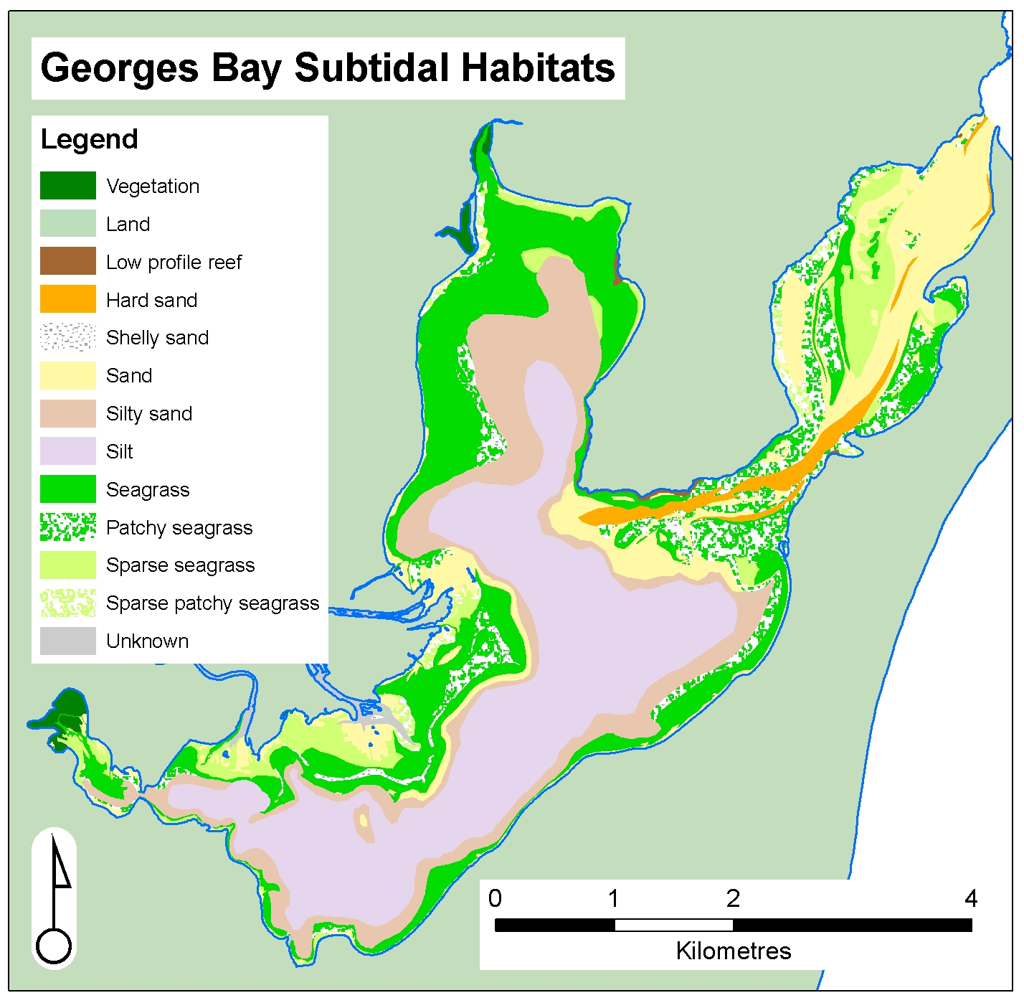.

Fig. 2. Map of subtidal habitats in Georges Bay (from Mount et al (2005).

Basic measures of ecosystem condition

Temperature
Temperature and salinity are recommended for monitoring, largely to supply supporting information, rather than as indicators themselves of CEM condition. Both temperature and salinity affect many physical, chemical and biological characteristics and processes with an estuary or coastal waters. As they both affect dissolved oxygen concentration, temperature and salinity must be recorded in conjunction with measurements of dissolved oxygen.

Water temperature is a key factor controlling the rate of biological processes. An increase or decrease in temperature can have substantial effects on the physiology of the fauna and flora and aquatic ecosystems functioning. Temperature recorded over long periods of time (years) is an indicator for global warming.

Water temperature can be measured using a thermometer or a field meter. It is also measured
by salinity and dissolved oxygen meters and instructions for using these field meters are given below.

Basic measures of ecosystem condition

Salinity (Electrical conductivity)

Salinity is a measure of the amount of salt in water. It is an indicator used to understand the hydrodynamics and mixing processes occurring in an estuary. Salinity is also important in the ecology of an estuary as many organisms can only survive within a limited salinity range. It is a key indicator of environmental flows into estuaries.

Seawater is measured by marine biologists as parts per thousand or PSU (Practical Salinity Units). Full seawater has a salinity of approximately 35 parts per thousand (ppt). However, most people working on freshwater systems measure salinity as electrical conductivity in microSiemens/cm. Full seawater is typically 51,500 µS/cm.

Salinity is generally measured using a field meter, although it can also be measured using a refractometer or a hydrometer which records specific gravity. The advantage of a field meter is that the salinity probe is attached by a cable to the meter and thus can be used to profile salinity values from the surface to the seabed. Because freshwater is less dense than seawater it generally flows over the top of saline waters and in this situation salinity increases from the surface towards the seabed.

How to Measure

Step 1. Ensure probe cable is connected securely to meter. Press power key to activate meter. Wait until screen displays 0.00 SAL before putting probe into the water.

Step 2. Lower probe into water and wait until display stabilises before taking both the salinity and the temperature reading.

Step 3. Remove probe from water and press power button again to switch off.

Trouble Shooting

- Screen displays measurement in uS/cm instead of SAL – press mode button once and it will switch to SAL.
- Screen displays 0.00 SAL despite probe being in water – water may have high fresh water content therefore very low salinity.
- Meter produces improbable measurement – meter possibly needs calibrating -refer to monitoring program co-ordinator.

Basic measures of ecosystem condition

Turbidity

Turbidity is a measure of the amount of suspended material in the water column, or cloudiness. Increased turbidity reduces the penetration of light in water and affects the depth at which submerged aquatic vegetation can grow. High turbidity levels may indicate erosion, sediment resuspension, wastewater discharge or algal blooms. Because increased turbidity commonly occurs as a result of altered land-based activities, such as land clearing, intensive agriculture, and urban development, it is an important indicator of estuarine condition.

Turbidity is commonly measured using a portable turbidity meter or a turbidity probe and the units of measurement are NTUs (Nephelometric Turbidity Units).

Measurement Notes
- Meter should not be removed from case for use.
- Meter needs to be placed on a flat steady surface when in use.
- Do not use in direct sunlight, cover with a cloth if necessary.
- Test samples immediately after collection.

How to Measure

Step 1 Remove three sample bottles from kit, rinse with seawater from the sample site, then fill each bottle to the rim with seawater from just below the surface, avoiding any debris floating at the surface.
Step 2. Each bottle should be cleaned gently on the outside with a lint free cloth to ensure the bottle surface is free from fibres and dirt. Do not use scratched bottles and do not shake or agitate the sample as this will introduce air bubbles.
Step 3. Open compartment lid and place sample bottle into cell compartment, aligning the diamond on the sample bottle with the notch beside the cell compartment.
Step 4. Press the “power” button. Wait until the screen displays 0.00 NTU and then press “read”
Step 6. The screen will flash for several seconds, wait until the reading has stopped flashing and the small light bulb symbol in the left of the screen has disappeared before recording the measurement.
Step 7. Press “power” button to turn power off before removing sample and repeating the process.

Trouble Shooting
- Flashing battery symbol – install new batteries.
- Error messages (displayed as E followed by a number) – refer to co-ordinator.
- Numeric display flashing, sample is too turbid for selected range – refer to co-ordinator.
- CAL? (flashing or non flashing) problem with the calibration of the machine – refer to co-ordinator.

Basic measures of ecosystem condition

Dissolved oxygen

The concentration of dissolved oxygen (DO) is an important measure of the health of an estuary. Decreases in DO are often related to increased organic load, such as from sewage, algal blooms and influx of organic matter into an estuary. This increase in organic load can lead to increased bacterial activity, resulting in greater oxygen consumption. As a consequence, the available oxygen, especially in bottom waters, can become depleted. It is thus important to measure dissolved oxygen in bottom waters.

Dissolved oxygen is commonly measured using a field DO meter and probe. These probes are sensitive and need to be carefully handled and maintained. Results can be reported as either mg/L or percentage saturation. Note: dissolved oxygen concentrations decrease with increased temperature and salinity. Thus temperature and salinity need to be measured at the same time as DO.

Measurement Notes
- Ensure probe cable is connected securely to meter.
- Display needs to read 100% or close to this in air before putting the probe into the water. Always allow the reading to stabilise before placing the probe into the water.

How to Measure

Step 1. Remove protective cap from probe.
Step 2. Press power button on meter. Display will show dissolved oxygen and temperature measurements on the top line and date and time on the bottom line. Wait until the dissolved oxygen measurement, displayed as 160%S or similar, drops to around 100%S before putting the probe into the water.
Step 3. Place the probe in the water. If there is no current move the probe around slowly so that water is flowing past the probe. Wait for the DO measurement to stabilise before recording both the DO and the temperature measurements.
Step 4. Record DO at the surface and close to the sea bed.
Step 5. Remove probe from water and press power button again to switch off. Ensure protective cap is replaced on probe.

Trouble Shooting
- Meter fails to reach 100% DO when switched on (either well above or below 100) – meter requires recalibration, refer to co-ordinator.
- Flashing battery symbol – battery needs recharging.
- Meter displays “off” and then switches off – not enough power to run meter, recharge battery.
- Meter will not turn on – battery completely flat, recharge battery.
- Meter reading will not stabilise in water – ensure there is adequate water flow past measuring probe.
- Inaccurate or unstable readings – meter needs recalibration, refer to co-ordinator.

Basic measures of ecosystem condition

Chlorophyll-a (additional training required)

Chlorophyll-a (Chl-a) is the green photosynthetic matter found in plants and thus is a measure of the biomass of plant material, mainly microscopic algae (phytoplankton) in the water column.

Chl-a is measured by taking water samples in the field and sending them to a laboratory for analysis using a spectrophotometer, These samples are collected either in a bottle just below the surface or as a depth integrated sample using plastic tubing.

The laboratories provide a 1 L plastic bottle for the water sample. When taking the sample the bottle should first be rinsed with the water from which the sample is to be taken. The bottle should be faced into the current or flow ensuring water does not pass across the hands before it enters the bottle. After the sample is taken it should be kept cool (on ice), wrapped in aluminium foil and transported to the lab as quickly as possible.

The Waterwatch Australia National Technical Manual Module 7, Estuarine Monitoring, (2006) provides a detailed description of how to filter the water sample in the field and submit the concentrated chlorophyll-a sample on filter paper to a laboratory for analysis. Note that it is important to keep the vacuum pressure at -20 kpa; if the pressure is too high the algal cells will be broken and sucked through the filter paper. This procedure does, however, require some scientific knowledge and training. The main advantage of filtering the sample is to reduce the costs of analysis. However, Analytical Services Tasmania cannot provide a result meeting their guaranteed laboratory standards as they have not filtered the sample.

.

Community monitoring

Algal blooms

Chlorophyll-a is the agreed first priority quantitative measure of algal biomass as it is widely used and the results are easily interpreted. However, because algal blooms are generally infrequent and unpredictable, information collected by on-the-spot community groups can be extremely valuable.

Algal blooms take two forms:
- Microalgae (phytoplankton) in the water column. Microalgae are too small to be individually seen by the naked eye, and these blooms are observed as regions of coloured water; for example green/brown water that can occur in estuaries or the obvious fluorescent pink blooms of Noctiluca scintillans.

- Macroalgae in shallow water and the intertidal zone. Some species of macroalgae proliferate in areas of high nutrients, leading to dense algal mats These include the sea lettuce (Ulva sp.), the green slimy algae (Enteromorpha sp.) and filamentous algae attached to other plants or the seabed, such as Chaetomorpha sp.

How to measure:

This is primarily a visual assessment for microalgae and macroalgae..
Equipment required: camera, GPS (if available), sealable bottle, rubber gloves, esky with ice.

Record details of the algal bloom or unusual event, including:
- location of the bloom using either GPS or a map of the bay or in relation to an important feature such as Humbug Point.
- Date and time
- Weather and tidal conditions
- Sketch a map of the area of the bloom, indicating any landmarks.
- Take photos of the bloom
- Algal species (if known)
- Make notes of any unusual conditions, eg odours, mortalities of fish etc

Take a sample of the algae if identification of the species is required. Use a clean sample container, rinse it several times in the water at the bloom site and then take the algal sample. Wear protective gloves during sampling in case the alga is toxic. If the sample is macroalgae it may require seawater to be added to keep the alga alive. Store the sample on ice, away from light. Do not freeze as this can cause algal cells to burst. With the assistance of the monitoring co-ordinator get the sample to a laboratory as soon as possible for identification of the species.
However many macroalgae found in Tasmania are difficult to identify.

Note: algal blooms can occur naturally and are not necessarily an indication of human impact or degradation. Some phytoplankton blooms occur with species that produce toxins, which can irritate skin or cause respiratory distress. Take appropriate precautions when handling algal bloom samples.

Community monitoring

Mass Mortalities

This indicator is primarily for community monitoring because it relies on reports of sporadic mass mortality events that would not normally be picked up in a routine monitoring program. Such information can be extremely useful in identifying a pollutant source or cause of harm to marine and estuarine flora and fauna.

Fish or invertebrate kills (e.g. crabs) are unexpected and generally short lived events that are conspicuous by the death of a large number of animals. The frequency and magnitude of such events is an indicator of the health of an estuary. Causes include low dissolved oxygen levels, disease, toxic algae, pollutant spills or uncommon weather patterns.

How to measure:
Record as much information as possible at the site and surrounding area, and report the incident to the appropriate management authority (e.g. local council, Parks and Wildlife Service, Environment Division or Marine Resources Division of State Government). Any death, stranding or injury of threatened species, marine mammals or seabirds must also be reported to the Marine Conservation Unit of the Department of Primary Industries and Water .

- Take photographs of the dead animals and the area affected.
- Record the location and estimated size of the area affected.
- Record the date and time of assessment.
- Record the current weather conditions and for the previous 48 hours.
- Note any recent activities that have occurred in the vicinity of the mass kill.
- Count or estimate the number of dead animals of each species present and record their size. If there are large numbers of dead animals, measure off approximately five smaller areas and count the number of dead animals of each species in each area. Take the average of these counts and extrapolate to the total affected area to estimate the total number of mortalities.
- Record the presence of other animals in the area, including sick or dying animals and any with skin lesions or wounds.
- Record the presence of any unusual materials in the area, such as oils slicks, discoloured water, rubbish etc. and any activities occurring in the vicinity of the kills.
- If you have the equipment, record temperature, salinity, dissolved oxygen, pH and take water samples in clean plastic bottles for possible subsequent analysis. If appropriate take samples of sediment, oil, sludge or other foreign material and store in glass jars.
- Carefully collect samples of dying or very recently dead animals for analysis using protective rubber gloves (animal tissue breaks down very quickly after death and rapidly becomes unsuitable for analysis). Store dead fish and small invertebrates in plastic bags and keep on ice or deep freeze if the sample will not be analysed within 24 hr.
- All samples should be accurately and comprehensively labelled with the date, time, location, species, nature of sample, person who collected the sample etc.
- A mass mortality data sheet is provided in Appendix B.

Note : collect samples of dead and dying animals with extreme care so that you do not come in contact with any contaminants.

Community monitoring

Shoreline Position

Sediments naturally move around an estuary or on the open coast as a result of water currents and wave action. However, many human activities markedly affect sedimentation and erosion rates, including land clearing, land reclamation, dredging, and construction of jetties and other artificial structures. Shoreline positions are also likely to change as a result of climate change and global warming.

The Tasmanian Shoreline Monitoring and ARChiving project (TASMARC) has been developed to provide information on shoreline movement of a selected group of Tasmanian beaches through measurement of (i) high water mark and (ii) beach profile. The methodology is explained at the website http://staff.acecrc.org.au/~johnubter/tasmarc.pdf, and has been developed for community groups.

As part of a project lead by Dr John Hunter from the University of Tasmania, shoreline monitoring will be conducted in collaboration with community groups at Georges Bay in late 2007 or early 2008.

The high tide mark measurement involves measuring the distance of the perceived high water mark from a fixed survey mark. The high water mark is defined as the most landward position of the shoreline over a period of approximately one month.
Similarly the measurement of the beach profile involves measuring the height of the beach relative to the surveyors mark. Both these measurements use survey marks which need to be within a measurable distance to the shoreline and are relatively easy to access. A suitable site close to a state survey mark has been identified at the corner of the Tasman Highway and St Helens Point Road.

Community monitoring

Litter

Litter, whilst not an estuarine health risk per se, can result in animal deaths, habitat degradation and associated health risks to the general community. Toxic substances leaching from litter can also accumulate in the food chain resulting in health risks to a wide variety of marine organisms. Many species of endangered marine mammals, turtles and seabirds are particularly at risk from water borne litter.

Sources of litter range from direct dumping onshore and rubbish dumped or abandoned from commercial or recreational fishing, through to stormwater and windblown detritus.

Measurement notes

Sites selected for litter monitoring should be easily accessible, not involved in any other cleaning operation, and subject to litter accumulation.

How to Measure

Equipment list:
- GPS or topographic map
- 100 m measuring tape or trundle wheel
- Data sheets, clipboards and pencils
- Digital camera
- Appropriate clothing (heavy duty gloves and protective shoes)
- Heavy duty plastic bags
- Special container for sharps
- Scales accurate to 0.1 kg

At each site set up a transect line using the tape measure. Each transect should run from the low tide mark to the top of the beach. Record the length and GPS co-ordinates of each transect, and take photos along the transect before commencing litter collection. Collect all visible litter within 5 m either side of the transect and then sort into categories. Categories include glass, cans, plastic bottles, plastic bags, other plastics, rope, paper and cardboard, fabrics, metal, cigarette butts and miscellaneous. Count the number of items in each category. Remove sand and fouling from the waste and weigh each category. Repeat this transect twice at each site (3 transects per site).

Community monitoring

Invasive species

Invasive plants and animals are those that do not naturally occur in an area or those that have increased in number to the extent that they are altering the natural ecosystem. Most invasive species have been introduced by human activity.

There are 58 introduced marine species that have been identified in Tasmania, 10 of which are recognised as marine pests. The Department of Primary Industry and Water (DPIW) maintains a database of invasive marine species found in Tasmania. This includes the Pacific seastar, Asterias amurensis, New Zealand screw shell, Maoricoplus roseus and the Japanese seaweed, Undaria pinntifiata, as well as the less obvious but regionally abundant introduced species such as the small bivalves, Cobula gibba, Theora lubrica, Raeta pulchella and the European/green shore crab, Carcinus maenas.

A port survey for invasive species has been conducted at St Helens and a number of invasive species have been identified from Georges Bay. These include:

- Northern Pacific seastar Asterias amurensis
- European green crab Carcinus maenas
- European clam Varicorbula gibba
- Bag mussel Musculista senhousia
- Japanese kelp Undaria pinnatifida
- New Zealand screwshell Petrolisthes elongates
- Toxic dinoflagellate Gymnodinium catenatum

Community-based monitoring of invasive species is likely to be conducted as part of monitoring other indicators and the objective is to add to the existing database of location and abundance of invasive species. Identification of and information on invasive marine species in Tasmania can be obtained from fact sheets provided by DPIW (available at the training session) and from CSIRO at http://crimp.marine,csiro.au//Marine_pest_infosheets.html

Experts at the Queen Victoria Museum in Launceston and the Tasmanian Museum and Art Gallery in Hobart can assist with the identification of invasive marine species. Any new discoveries of invasive species or extensions in distribution beyond the known range should be reported to DPIW.
Important indicators

Nutrients in the water column (additional training required)

Nitrogen and phosphorous are essential building blocks of animal and plant life and are cycled through the environment by biological and chemical means. In the marine environment nitrogen is often the limiting nutrient for growth, whereas in freshwater it is mainly phosphorous.

If funding is limited it is recommended that biologically available dissolved nutrients (nitrate + nitrite, phosphate and ammonium) are monitored as a priority. However, if sufficient funding is available and information is required on nutrient loads from rivers into estuaries, total nitrogen (TN) and total phosphorous (TP) should also be monitored.

Water samples for ammonium analysis are easily contaminated and great care must be taken in collecting these samples. For example, they can not be collected by a smoker because nitrogenous tar on fingers can contaminate samples. Similarly, water samples need to be collected away from the exhaust of outboard motors.

Water samples are sent to the State Government Laboratories (Analytical Services Tasmania, AST) at Sandy Bay in Hobart for nutrient analysis. The laboratories provide sample bottles, filters as required, information on how to collect and process the water samples in the field, and guidance on how long samples can be stored before analysis. Water samples for nutrients are either delivered fresh to the laboratory on the day of sampling or refrigerated at 4º C (filtered samples can be frozen), and delivered later. However, silicate samples can not be frozen.

How to measure

Dissolved nutrient tubes are 50ml red screw cap tubes accompanied by a yellow disc filter and disposable 30ml luer lock tip syringes. Begin by ensuring the tube is labelled correctly with the date, time, site, location etc. Remove a new 30ml syringe from its individual wrapper and fill syringe with water sample. Attach a yellow filter to the end of the syringe and then push the water sample through the filter into the red tube. Immediately replace the cap on the tube and store the tube on ice.

Measurement Notes

A new disposable syringe and filter must be used for each water sample taken. Fill the syringe only to capacity and discharge into tube – do not add any more water to fill the tube. Avoid touching the syringe or filter tips, or the inside of the nutrient tube cap. Smokers should not take samples as chemicals on the fingers can contaminate the samples collected. If samples cannot be transported to a laboratory immediately, they need to be frozen.

Important indicators

pH

pH measures acidity or alkalinity of water on a log scale from 0 (extremely acidic) to 14 (extremely alkaline). A pH of 7 is neutral and most CEM organisms prefer a pH in the range of 7-8.5. pH is generally relatively stable in estuarine and marine waters because of carbonate buffering. However, significant changes in pH may occur due to disturbance of acid sulphate soils from mine drainage or chemical pollution.

An altered pH that is higher or lower than that normally encountered by marine organisms can result in tissue damage, leading to death. Changes in pH can also affect the availability of metals and the solubility of calcium carbonate, which is important for shell-forming organisms.

pH of water is generally measured in situ using a field meter with a pH probe. These field probes are generally robust and reliable provided they are well maintained and calibrated.

Measurement Notes

- Instrument should be held upright when measuring. Only the measurement probe should be placed into the water. Do not immerse entire instrument in water.

How to Measure

Step 1. Remove black cap from end of meter.

Step 2. Press power button to switch on.

Step 3. Hold the meter in the water and observe the display. Once display has settled measurement can be recorded.

Step 4. Press power button to switch off and replace black cap.

Trouble Shooting

- Battery light is displayed – install new batteries.
- Inaccurate/instable readings – meter may need recalibration, refer to co-ordinator.
- Temperature measurement is displayed in Fahrenheit instead of Celsius – refer to co-ordinator.
Important indicators

Animal or Plant Species Abundance

Animal or plant species abundances are important measures of estuarine health and water quality. This is because physical and chemical measures of water quality can vary rapidly (within 24 hours) due to changing environmental conditions, such as flooding into an estuary. By contrast, animal and plant species abundance generally do not change so rapidly and are therefore a better integrator of environmental conditions over time.

In estuaries, the dominant habitat type is soft sediment and assessment of estuarine invertebrate fauna living in sand and mud sediments has been identified as a good indicator of water quality and estuarine health. These infauna do not regularly move around and are not readily dislodged (compared with fish or surface dwelling invertebrates).

Community-based monitoring of soft sediment fauna and seagrass

A simplified method of sampling invertebrate fauna in the sediments around fish farms, which is suitable for trained farm hands to use, has been developed by TAFI. This is documented in the ‘Guide to the assessment of sediment condition at marine finfish farms in Tasmania’ by Macleod and Forbes, (2004), available at http://www.utas.edu.au/tafi/TAFI_Download.htm#TAFI%20Technical%20Reports, TAFI Reports to Funding/Other Bodies. It is highly probable that this methodology could be adapted for community groups and this will be examined in Georges Bay at a later date.

Community-based monitoring of seagrass beds is relatively common in mainland Australia, but has not occurred in Tasmania, presumably because of the colder water, low tidal range around much of the coastline and limited distribution of extensive seagrass beds near the higher populated areas. A useful manual for community monitoring of seagrass is the Parks Victoria Technical Series No. 16, Sea Search: Community-based monitoring of Victoria’s marine national parks and marine sanctuaries – Seagrass monitoring by Koss et al (2005) available at http://www.parkweb.vic.gov.au/resources/19_1326.pdf. This report describes seagrass species commonly found in Tasmania. However, the methods used to monitor seagrass condition are slightly different to those that have been employed in Tasmania.

Seagrass condition naturally changes between seasons and thus seasonal monitoring is necessary if these natural trends are to be identified. Annual monitoring in Tasmania, however, may be preferred to avoid the cold winter conditions. For annual monitoring it is important to monitor at the same time each year to avoid the seasonal changes.

Although sea grass communities are susceptible to changes in water quality and thus are widely considered to be an important indicator of environmental health, differences between species in their ecology and reproduction need to be taken into consideration when assessing abundance data.

Community monitoring of seagrass in Georges Bay is not currently planned but could be investigated if there is significant interest from community members.

Important indicators

Toxicants: sediment, water column, biota

Toxicants are chemicals that are harmful to the fauna and flora of estuaries and coastal waters. They can be natural but toxic at high concentrations or man-made substances. Toxicants can be in the sediments, in the water column or in animal/plant material.

Measurement of toxicant concentrations generally requires sophisticated equipment which is available in only a few laboratories. It is also usually expensive to measure, hence is generally only monitored when there is a specific reason to do so. A systematic approach is required where potential toxicants are identified and the monitoring program must be carefully designed in terms of where and when to monitor to ensure cost-effectiveness and sufficient data are available to verify changes.

For Georges Bay the best methods for monitoring toxicants are currently being investigated.

Important indicators

Pathogens

Pathogens are organisms such as bacteria, viruses, protozoans or fungi that cause disease in human and estuarine/marine organisms. Exposure to pathogens can occur in several ways, either directly through physical contact or indirectly through consumption of contaminated organisms such as shellfish. The main sources of pathogens are from warm-blooded animals, including humans, which can be concentrated in sewage and storm water overflows, and in areas receiving animal wastes, such as downstream of intensive dairy farming.

In Georges Bay the two main sources of information on pathogens has been through (i) Tasmanian Shellfish Quality Assurance Program (TSQAP), which has been monitoring thermotolerant coliforms in shellfish growing waters for many years to assess whether the shellfish are safe for human consumption, and (ii) local councils who monitor recreational beaches for primary contact, especially over the warmer months. No additional sampling for pathogens is currently planned.

If additional sampling for pathogens is required, the Waterwatch Australia National Technical Manual Module 7, Estuarine Monitoring, (2006) describes test kits for bacterial analysis which are available commercially. These include presence-absence kits and plating for counts of bacteria. The Waterwatch Tasmania – Equipment guide 2003 describes and provides prices for an easy method for identification and counting general coliform and E. coli colonies. It also describes the membrane filtration method which allows accurate counts of low numbers of faecal bacteria.

A new product B2P TM on the market suitable for bacterial testing by community groups enables testing to be conducted on the spot. The water sample jars contain chemicals which specifically test for coliforms and E. coli and the rate of change of colour of the sample solution is related to the concentration of bacteria. This product is available from scientific suppliers and costs $25 per sample container. A similar product is available for testing coliforms and E. coli in foods, including shellfish; cost approx $30 per sample.

Note that the sites monitored and default trigger values for pathogens are in relation to human health risk and not environmental risk.

Appendix A: Water quality monitoring data sheet

Date: _________________Time: _________________________

Samplers Name(s): _____________________________________________________

Site name:____________Tide:____________________________________________

Weather: _____________________________________________________________

pH:___________ Turb 1:____________Turb 2:____________Turb3:_____________

Depth | Salinity | Temp | DO | Temp
0
1
2
3
4
5
6
7
8
9
10
11
12
13
14
15
16
17
18
19

Notes:___________________________________________________________________________________________________________________________________________________________________________________________________________________________________________________________________________________________________________________________________________________
_____________________________________________________________________
_____________________________________________________________________

Appendix B: Mass mortality data record

Date _________________Time _________________________

Water body___________________________________________________________

Location __________________________GPS Coordinates_____________________

Weather (temperature, rainfall, wind) _____________________________________

Collectors Name(s) and Address __________________________________________

____________________________________________________________________

Animal Species Affected:________________________________________________

Time of death? Dying / Hours / Days? ______________________________________

Area covered by dead/dying animals:_______________________________________

Estimated no. of dead animals:____________________________________________

Size / Length of affected animals? ______________________________________

Behavioural abnormalities? (lethargic? swimming near surface?)________________

____________________________________________________________________

External abnormalities? (Lesions / fungus / pigment discoloration/ etc.)____________

_____________________________________________________________________

Other Animals Affected: Amphibians / Decapods / Invertebrates / Mammals, Other?

_____________________________________________________________________

Water Assessment: Current flow rate and direction____________________________
Temperature _____________ Dissolved Oxygen ____________ pH ______________
Salinity_________________Turbidity _____________________________________
Water Colour ____________ Algal blooms?_________________________________
Floating matter, scum___________________________________________________
Visible Discharges _____________________________________________________

Recent weather events (storms, floods, droughts______________________________

Adjacent land use and recent activities in vicinity of kill?___________________

_____________________________________________________________________

Samples Collected: ( Yes or No )

Fish ___________________ Water_______________ Sediment _________________ Algae __________________Other ________________________________________

Pictures of dead or diseased fish taken? _____________________________________

Additional information: _________________________________________________ __________________________________________________________________________________________________________________________________________
__________________________________________________________________________________________________________________________________________
__________________________________________________________________________________________________________________________________________
__________________________________________________________________________________________________________________________________________
__________________________________________________________________________________________________________________________________________
__________________________________________________________________________________________________________________________________________

Map of fish kill area. Include sampling sites, sites photographed and direction, landmarks, direction of water flow, vegetation and north arrow.

